**Abbreviations**

**AC:** Attributable number of cases

**ACBS:** Asthma all Back Survey

**AF:** Attributable fraction

**BRFSS:** Behavioral Risk factor Surveillance System

**CDC:** Center for Disease Control and Prevention

**D.C.:** District of Columbia

**EPA:** United States Environmental Protection Agency

**U.S.:** United States

**LUR:** Land use regression

**NHGIS:** National Historical Geographic Information System

**PAF:** Population attributable fraction

**IR:** Incidence rate

**PRV:** Prevalence rate

**TRAP:** Traffic related air pollution

**Introduction**

**Haneen to write 1000 words**

**Methods**

In this paper, we aim to estimate the burden of childhood asthma due to NO2 exposure using state specific asthma incidence rates and compare the change in burden estimates from those produced by Alotaibi et al. (2019) which used a country level asthma incidence rate, as is typically done in burden of disease assessment studies (Achakulwisut et al., 2019; H. Khreis, de Hoogh, et al., 2018; H. Khreis, Ramani, et al., 2018; Perez et al., 2013; Perez et al., 2009).

*Study area and time point*

We analyzed data for the 49 states within the contiguous United States (U.S.) and the District of Columbia (D.C.) for the year 2010 at the census block level: the smallest geographical unit available. Population counts, urban or rural living location and annual NO2 concentrations were all available at the census block level. However, median household income was available at the census block group level, which is one level higher than the census block (US Census Bureau, 2010). Childhood asthma incidence rates were available at the state level. NO2 concentrations were not available for states outside the contiguous U.S. (Alaska, Hawaii and Puerto Rico), and hence these states were excluded from the analysis.

*Census data*

We included populated census blocks of the contiguous U.S. for the year 2010, as obtained from the National Historical Geographic Information System (NHGIS) website (Manson et al., 2018; US Census Bureau, 2010). Each block included information on the total population of children <18 years old, and whether the census block was designated as an urban or a rural block. Census-designated urban areas were defined by the census bureau using multiple criteria including total population thresholds, density, nonresidential urban land use (e.g. paved areas and airports), and distance to other urban developed areas (US Census Bureau, 2016). Census blocks are the basic geographical units of urban areas. Further, census-designated areas are classified into two subtypes; urban clusters or urbanized areas. Urban clusters have a population threshold of ≥2,500 and <50,000, while urbanized areas have a population threshold of ≥50,000 people. The median household income in the past 12 months using 2010 inflation adjusted dollars was divided into five categories consistent with two previous relevant publications: <$20,000, $20,000 to <$35,000, $35,000 to <$50,000, $50,000 to <$75,000 and ≥$75,000 (Alotaibi et al., 2019; Clark et al., 2017). Census blocks were than assigned a similar median household income of the census block group they reside under.

There were 2,686 (0.04%) census blocks with missing median household income data in 2010. These census blocks were assigned a “Not defined” status in the analysis of median household income. Table 1 summarizes the geographical and demographic data across all census blocks included in this analysis.

*NO2 exposure assessment*

Annual average NO2 concentrations for each populated census block were available at the centroid location for the year 2010.

Concentrations were derived from a land use regression model developed by (Bechle et al., 2015). The model incorporates spatial and temporal air pollutant data. The spatial aspect is derived from the U.S. Environmental Protection Agency (EPA) air quality monitoring data, satellite data and several GIS covariates including impervious surfaces, elevation, major, minor and residential roads, and distance to cost. The temporal data is scaled using average monthly monitor readings for 11 consecutive years. The model achieves a relatively high predictive power using hold-out cross validation when compared to similar land use regression models (Beelen et al., 2009; Hystad et al., 2011; Novotny et al., 2011; Vienneau et al., 2013) with an R2 reaching 82%. The LUR use regression model has been used in multiple studies including (Alotaibi et al., 2019; Clark et al., 2017). A detailed description of the model can be found at Bechle et al. (2015). NO2 concentrations were converted from ppb to ug/m3through multiplying by 1.88 (WHO, 2005). Exposure data was matched with census blocks using a unique identifier for each census block.

*Concentration-response functions*

We used an asthma development concentration-response function (CRF) of 1.05 (95% CI = 1.02-1.07) per 4 ug/m3 of NO2. The CRF was obtained from a meta-analysis of 20 studies examining the association between exposure to traffic-related air pollution (TRAP) and the risk of developing asthma among children from birth to 18 years of age (H. Khreis et al., 2017). These CRF represent data from the most up-to-date and widest analysis on traffic-related air pollution and the onset of childhood asthma, and have been used in several published peer-reviewed burden of disease assessments (Achakulwisut et al., 2019; Alotaibi et al., 2019; H. Khreis, de Hoogh, et al., 2018; H. Khreis, Ramani, et al., 2018; H. C. Khreis, Marta; Mueller, Natalie; Kees de Hoogh; Hoek, Gerard; Nieuwenhuijsen, Mark J; Rojas-Rueda, David;, In prep).

*Asthma incidence and prevalence rate*

An incidence rate is defined as the number of new cases of a disease within a specified time period among an at-risk population (Mausner et al., 1985). To estimate the aggregate childhood asthma incidence rate for the year 2006 through 2010 among U.S. states, we obtained the Behavioral Risk Factor Surveillance System (BRFSS) and Asthma call Back Survey (ACBS) child (CDC, 2009, 2011) data sets for the years 2006-2010 from the Center for Disease Control and Prevention (CDC) website <https://www.cdc.gov/brfss/> and followed the methods described by Winer et al. (2012) (Figure 1). The following variables were extracted: the state, asthma status question (BRFSS), incident status question (ACBS), and children sample weights. All analysis was conducted using R statistical software (R Core Team, 2018). States and territories not within the contiguous U.S. were excluded from the analysis, namely Alaska, Hawaii and Puerto Rico.

To determine the “Asthma status” of children, respondents to the BRFSS were asked “Has a doctor, nurse, or other health professional EVER said that the child has asthma?”, If the answer was “Yes”, the respondent was designated as “Ever asthma” and If the answer was “No”, the respondent was designated as “Never asthma”. Respondents with children designated as “Ever asthma” were requested to participate in the ACBS follow up survey. To determine the “Incident status” of children, respondents to the ACBS survey were asked: “How old was the [name of child] when a doctor or other health professional first said [he/she] had asthma? How long ago was that?” If the answer to the latter part of this question was “within the past 12 months”, the respondent was designated as an “Incident asthma”, while other responses were not relevant to the analysis.

Each respondent (sample) from the BRFSS and ACBS was assigned a weight to adjust for the disproportionate population sample selection relative to the state’s overall population distribution, the variation in probability of selection, the actual response of each respondent, or nonresponse . The weight of each sample represents the number of children within each state, with similar characteristics to the sample. Weights are used to convert samples to population estimates of children. For example, if respondent (X) had a weight of 150, her/his response to survey questions represent answers of 150 children within their state. The sum of childhood weights for the BRFSS represent the total population of children within each state, while the sum of weights for the ACBS represent the total population of children with “Ever asthma” within each state.

“At-risk children” were then estimated by taking the weighted sum of respondents designated as “Incident asthma” and “Never asthma”, as shown in Equation 1.

Equation 1

The asthma incidence rate was the product of weighted “Incident asthma” divided by “At-risk children”, as shown in Equation 2.

Equation 2

The asthma prevalence rate was the product of weighted “Ever asthma” divided by the sum of weighted “Ever asthma” and weighted “Never asthma”, as shown in Equation 3.

Equation 3

The asthma incidence rate was then aggregated across the all available years by taking the sum of weighted “Incident asthma” divided by the sum of “At-risk children” for the years 2006 through 2010, as shown in Equation 4.

Equation 4

The aggregate asthma prevalence rate across all the states during the same time period was estimated as shown in Equation 5.

Equation 5

To obtain the state-specific asthma incidence rates we used the above equations for each state. States that did not participate and/or did not have available data in the ACBS during the period 2006 through 2010 (n = 19 states) were assigned the aggregate asthma incidence and prevalence rate (Table S2).

*Burden of disease estimation*

To estimate the burden of disease, we followed the methods described in Alotaibi et al. (2019) with the following steps:

The total at-risk children residing in a census block was estimated for each state by subtracting the total number of children within the census block from the total children within the census block multiplied by the state-specific prevalence rate, as shown in Equation 6.

Equation 6

We then estimated the number of childhood asthma cases within each census block by multiplying the state-specific aggregate asthma incidence rate by the at-risk children at the census block level, as shown in Equation 7.

Equation 7

We then calculated the relative risk (RRdiff) for asthma due to the exposure difference between the estimated exposure levels from the land use regression model (NO2 concentration at the census block level) and no exposure (zero concentration for NO2), as shown in Equation 8.

Equation 8

Where RR is the CRF and RRunit is the exposure unit (4 ug/m3) for the CRF as extracted from H. Khreis et al. (2017). The population attributable fraction (PAF) is then estimated using Equation 9:

Equation 9

The attributable number of asthma incident cases (AC) was estimated by multiplying the PAF with the total number of incident asthma cases at each census block, as shown in Equation 10.

Equation 10

The attributable number of cases for each census block is summed across the state, and the entire country, to get the total AC, as shown in Equation 11.

Equation 11

**Results**

*NO2 concentrations and trends*

The mean (min-max) NO2 concentrations were 13.3 (1.5-58.3) ug/m3 (Table 2). By living location, the mean NO2 concentration was highest in urbanized areas (18.4 ug/m3) (Figure S1), while mean NO2 concentration was highest among the highest median income group of ≥$75,000 (16.5 ug/m3) (Figure S2). When stratifying NO2 concentrations by median income groups but separately for each living location, rural areas had an increasing average concentration as income increased, urban clusters has a decreasing average concentration as income increased while urbanized areas showed a U-shaped trend (Figure S3 and Figure S4). South Dakota had the lowest mean NO2 concentration (5.2 ug/m3), while the District of Columbia had the highest (26.3 ug/m3) (Table S1 and Figure S5). Figure S6 and Figure S7 demonstrates NO2 concentrations across living location and median household income for each state.

*ACBS and BRFSS results*

Overall, there were 32 states with available childhood asthma incidence rates (Table 3 and Table S3). The total childhood samples included for the period (2006-2010) were 293,464 samples from the BRFSS and 16,156 samples from the ACBS. The BRFSS samples for each year ranged between 55,094 samples in 2006 and 61,862 in 2008. While the ACBS samples for each year ranged between 2,016 samples in 2006 and 4,095 in 2009. The weighted estimates represent the childhood population counts of available states from the ACBS and the BRFSS for the year which the survey was conducted.

The overall aggregate asthma incidence rate for the years 2006-2010 was 12.1 per 1,000 at-risk children. The state of Montana had the lowest aggregate childhood asthma incidence rate (IR = 4.3 per 1,000 at-risk children), while District of Columbia had the highest aggregate childhood asthma incidence rate (IR = 17.7 per 1,000 at-risk children). States that did not have an incidence rate available (16 states) were assigned the overall aggregate asthma incidence rate of 12.1 per 1,000 at-risk children (Table S2).

*Asthma incident cases*

Using state-specific asthma incidence rates, the estimated number of childhood asthma incident cases were 754,893 in 2010 (Table 4). By living location, 19% lived in a rural area, while 9% and 72% lived in an urban cluster and urbanized area, respectively. The largest percentage of childhood asthma cases (28%) lived in an income block group of $50,000 to <$75,000, while the lowest percentage (4%) lived in the lowest income block group of <$20,000. The state with the lowest number of estimated childhood asthma incident cases was Montana with 900 cases, while the state with the largest number was Texas with 99,100 cases (Table S4).

*Attributable number of cases and fraction*

On average, we estimated a total of 132,829 childhood asthma cases attributable to NO2 exposure which accounted for 17.6% of all childhood asthma cases (Table 4 ). By living location, urbanized areas had the largest number of attributable cases totaling 109,581 cases and the highest percentage of all asthma cases at 20.3%. Rural areas had total of 13,951 cases and accounted for the least percentage of all asthma cases with 9.8%, while urban clusters had only 9,296 cases representing 13% of all asthma cases (Figure S8). By income, $50,000 to <$75,000 had the largest number of cases attributable to NO2, 37,559 cases accounting for 16.8% of all asthma cases. However, the income group with the largest percentage of asthma cases was the lowest income group <$20,000, accounting for 20.8% of all asthma cases (Figure S9). The mean value of attributable fraction increased by income group in rural areas, decreased by income group in urban clusters and presented as a U shape in urbanized areas (Figure 2 and Figure S10).

The state with the lowest number of estimated attributable cases was Montana with 70 cases, while the state with the largest attributable cases was California with 19,200 cases. The state with the lowest attributable fraction was South Dakota (7.6%), while the state with the highest attributable fraction was District of Columbia (26.9%) (Figure 3 and Table S4 ).

Figure 4 and Figure 5 present the distribution of attributable fraction by living location and median income group for each state. The majority of states follow a distribution similar to the national level with a few exceptions (e.g. see Arizona, Montana, Rhode Island & Wyoming).

*Comparison with the main paper*

*Comparing total asthma cases*

Using state-specific asthma incidence rates, the overall number of cases reduced by an average of 40,041 (5%) cases compared to estimates in the main paper that used a flat national asthma incidence rate (Table 4). By living location, the largest reduction was among urban clusters with a decrease of 4,204 (5.6%) cases followed by urbanized areas which reduced by 29,926 (5.2%) cases. By income group, the largest decrease in the number of cases was among the highest income groups by 13,123 (6.8%) cases, while the least decrease was among the lowest income group by 168 (0.6%) cases. The state of California had the largest decrease in numbers of total childhood asthma incident cases by 24,442 cases while the state of Texas had the largest increase in numbers by 25,019 cases (Table S4). The state of Montana had the largest percent reduction in total childhood asthma incident cases by 64.1% while the state of Texas had the largest percent increase by 33.8%.

*Comparing attributable cases*

The total attributable cases reduced by 9,103 (6.4%) cases when compared to the main paper (Table 4). By living location, urbanized areas had the largest reduction by 8,040 (6.8%) cases, while rural areas had the least reduction by 514 (3.6%) cases attributable to NO2 exposure. By income group, the highest income group had the largest decrease in attributable cases by 2.994 (8.5%) and the lowest income group had the least decrease by 58 (1%) cases. The state of California had the largest decrease in attributable cases by 6,190 cases while the state of Texas had the largest increase by 3,615 cases (Table S4).

*Comparing attributable fractions*

The overall attributable fraction reduced 1.4% with urbanized areas having the largest reduction by 1.7% in terms of living location. In terms of income group, the largest reduction was 1.8% for both $50,000 to <$75,000 and ≥$75,000 (Table 4). The attributable fraction across states did not differ when using state specific asthma incidence rates.

**Discussion (bullet points)**

**Haneen to add 2000 words**

* Using state specific asthma incidence rates did not change the results much (within the range of the sensitivity analysis from the main paper)
* The state specific total number of asthma cases and attributable cases changed when applying state specific incidence rates
* The state-specific attributable fractions did not change. The reason is that the incident rate is applied uniformly across the state (spatially), thus the total asthma cases and total attributable cases will change with equal proportion when applying the new asthma incidence rate but not the attributable fraction. The attributable fraction is a function of CRF and exposure estimate regardless of the IR. Had we applied an incidence rate based on other factors like age, gender, race, income group, then the attributable fraction across the state would differ since the change won’t in incidence rate won’t be uniform within the state.
* The percentage of all asthma cases has a U shaped distribution when examining income groups. The lowest income group had the highest % then drops and rises again with the highest income group.
* Explore why the U shaped distribution is shown among attributable fraction for income groups.

**Conclusions**

***Tables***

Table 1: Census data description, year 2010

|  |  |  |
| --- | --- | --- |
| **Geographic characteristics** | **Total populated census blocks** | 6,182,882 |
| **Total census-designated urban areas** | 3,590,278 (58%) |
| **Demographic characteristics** | **Total population** | 306,675,006 |
| **Total population of children (birth – 18)** | 73,690,271 (24%) |
| **Mean (range) number of children in census blocks** | 12 (0-2214) |
| **Population of children by living location** | **Rural** | 13,763,183 (19%) |
| **Urban clusters (≥2,500 and <50,000 people)** | 6,994,464 (9%) |
| **Urbanized area (≥50,000 people)** | 52,932,624 (72%) |
| **Population of children by median household income** | **<$20,000** | 2,614,804 (4%) |
| **$20,000 to <$35,000** | 12,770,843 (17%) |
| **$35,000 to <$50,000** | 18,573,954 (25%) |
| **$50,000 to <$75,000** | 21,953,876 (30%) |
| **≥$75,000** | 17,763,239 (24%) |

Table 2: NO2 concentration (ug/m3) by strata

|  |  |  |  |  |  |  |  |
| --- | --- | --- | --- | --- | --- | --- | --- |
|  |  | **Mean** | **Min** | **25%** | **Median** | **75%** | **Max** |
| **Total** |  | 13.2 | 1.5 | 7.9 | 11.4 | 16.6 | 58.3 |
| **By living location** | **Rural** | 8.0 | 1.5 | 6.0 | 7.8 | 9.8 | 37.7 |
| **Urban cluster** | 12.0 | 1.6 | 9.6 | 11.9 | 14.2 | 35.6 |
| **Urbanized area** | 18.4 | 2.6 | 13.0 | 17.0 | 22.1 | 58.3 |
| **By median household income** | **<$20,000** | 16.1 | 2.0 | 10.4 | 14.9 | 20.1 | 56.8 |
| **$20,000 to <$35,000** | 13.2 | 1.6 | 8.1 | 11.7 | 16.7 | 58.3 |
| **$35,000 to <$50,000** | 11.8 | 1.5 | 7.0 | 10.0 | 14.5 | 58.0 |
| **$50,000 to <$75,000** | 12.8 | 1.6 | 7.6 | 10.8 | 15.7 | 55.7 |
| **≥$75,000** | 16.5 | 2.1 | 10.9 | 14.9 | 20.6 | 55.5 |

Table 3: Childhood asthma survey summary

|  |  |  |  |  |  |  |
| --- | --- | --- | --- | --- | --- | --- |
|  | **2006** | **2007** | **2008** | **2009** | **2010** | **Total** |
| **BRFSS sample (weighted)** | 55,094 (50,674,742) | 59,487 (43,661,381) | 61,862 (53,327,550) | 59,821 (47,747,373) | 57,200 (39,975,264) | 293,464 |
| **Ever asthma sample (weighted)** | 7,168 (6,493,224) | 7,971 (5,763,409) | 8,255 (7,218,400) | 8,126 (6,279,938) | 7,483 (5,158,455) | 39,003 |
| **ACBS Sample (weighted)** | 2,017 (4,580,870) | 2,797 (5,459,638) | 3,924 (4,343,245) | 4,095 (4,154,076) | 2,196 (3,116,669) | 16,156 |
| **Incident case sample (weighted)** | 154 (404,276) | 173 (312,917) | 169 (385,818) | 153 (297,546) | 160 (319,743) | 809 |
| **At-risk sample (weighted)** | 48,080 (30,825,589) | 51,689 (36,050,557) | 53,776 (26,491,259) | 51,848 (25,942,087) | 49,877 (22,900,850) | 255,270 |
| **Incidence rate\*** | 13.1 | 8.7 | 14.6 | 11.5 | 14.0 | 12.1 |
| **Prevalence rate\*\*** | 12.8 | 13.2 | 13.5 | 13.2 | 12.9 | 13.1 |
| **Number of states included** | 18 | 26 | 20 | 17 | 17 | 32*** |

*\*Aggregate asthma incidence rate per 1,000 at-risk children*

*\*\*Aggregate asthma prevalence rate per 100 children*

*\*\*\*Total number of states included in the aggregate asthma incidence rate.*

Table 4: Comparing results of the burden of disease using state-specific estimates vs original estimates

|  |  |  |  |  |  |  |  |  |  |  |  |  |  |  |  |  |
| --- | --- | --- | --- | --- | --- | --- | --- | --- | --- | --- | --- | --- | --- | --- | --- | --- |
|  |  | **Main results** | | | | **Original results** | | | | **Difference** | | | | **Percentage difference** | | |
|  |  | **Incident cases** | **AC** | **AF** | **Incident cases** | | **AC** | **AF** | **Incident cases** | | **AC** | **AF** | **Incident cases** | | **AC** | **AF** |
|  | **Total** | 754,893 | 132,829 | 17.6% | 794,934 | | 141,931 | 17.9% | -40,041 | | -9,103 | -0.3% | -5.0% | | -6.4% | -1.4% |
| **By living location (% of Total)** | **Rural** | 142,559 (19%) | 13,951 (11%) | 9.8% | 148,470 (19%) | | 14,466 (10%) | 9.7% | -5,911 | | -514 | 0.0% | -4.0% | | -3.6% | 0.4% |
| **Urban cluster** | 71,249 (9%) | 9,296 (7%) | 13.0% | 75,453 (9%) | | 9,844 (7%) | 13.0% | -4,204 | | -549 | 0.0% | -5.6% | | -5.6% | 0.0% |
| **Urbanized area** | 541,085 (72%) | 109,581 (82%) | 20.3% | 571,011 (72%) | | 117,621 (83%) | 20.6% | -29,926 | | -8,040 | -0.3% | -5.2% | | -6.8% | -1.7% |
| **By median household income (% of Total)** | **<$20,000** | 28,039 (4%) | 5,834 (4%) | 20.8% | 28,207 (4%) | | 5,892 (4%) | 20.9% | -168 | | -58 | -0.1% | -0.6% | | -1.0% | -0.4% |
| **$20,000 to <$35,000** | 134,208 (18%) | 24,906 (19%) | 18.6% | 137,765 (17%) | | 25,794 (18%) | 18.7% | -3,558 | | -889 | -0.2% | -2.6% | | -3.4% | -0.9% |
| **$35,000 to <$50,000** | 190,481 (25%) | 32,369 (24%) | 17.0% | 200,367 (25%) | | 34,549 (24%) | 17.2% | -9,885 | | -2,180 | -0.2% | -4.9% | | -6.3% | -1.4% |
| **$50,000 to <$75,000** | 223,522 (30%) | 37,559 (28%) | 16.8% | 236,827 (30%) | | 40,540 (29%) | 17.1% | -13,305 | | -2,981 | -0.3% | -5.6% | | -7.4% | -1.8% |
| **≥$75,000** | 178,497 (24%) | 32,133 (24%) | 18.0% | 191,621 (24%) | | 35,128 (25%) | 18.3% | -13,123 | | -2,994 | -0.3% | -6.8% | | -8.5% | -1.8% |

Figure 1: Childhood asthma incidence rate flow chart.

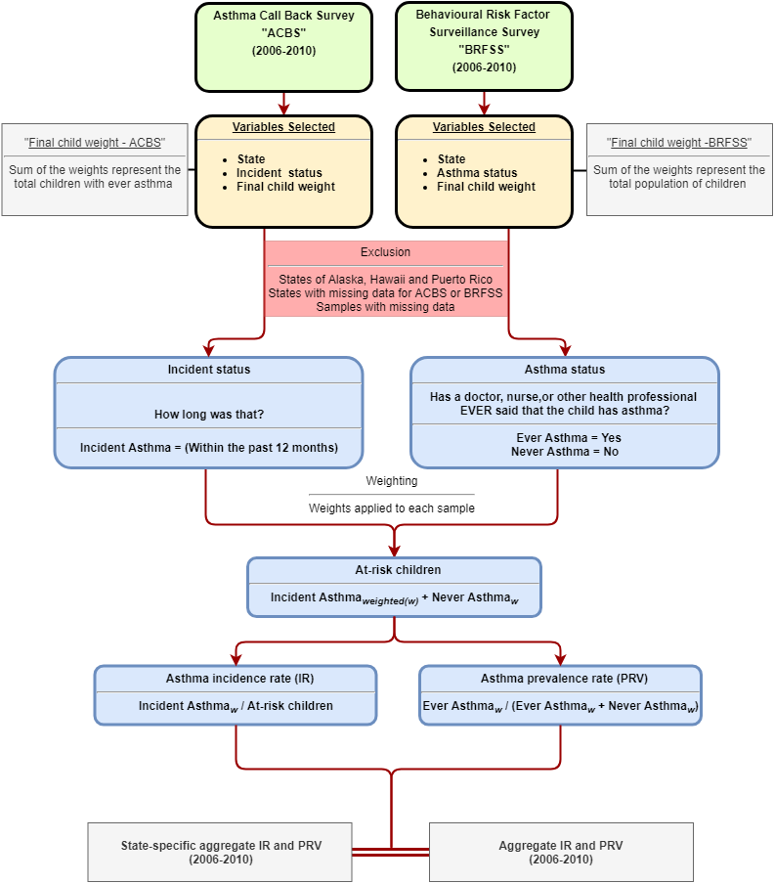

Figure 2: Attributable fraction by median income group stratified into living location

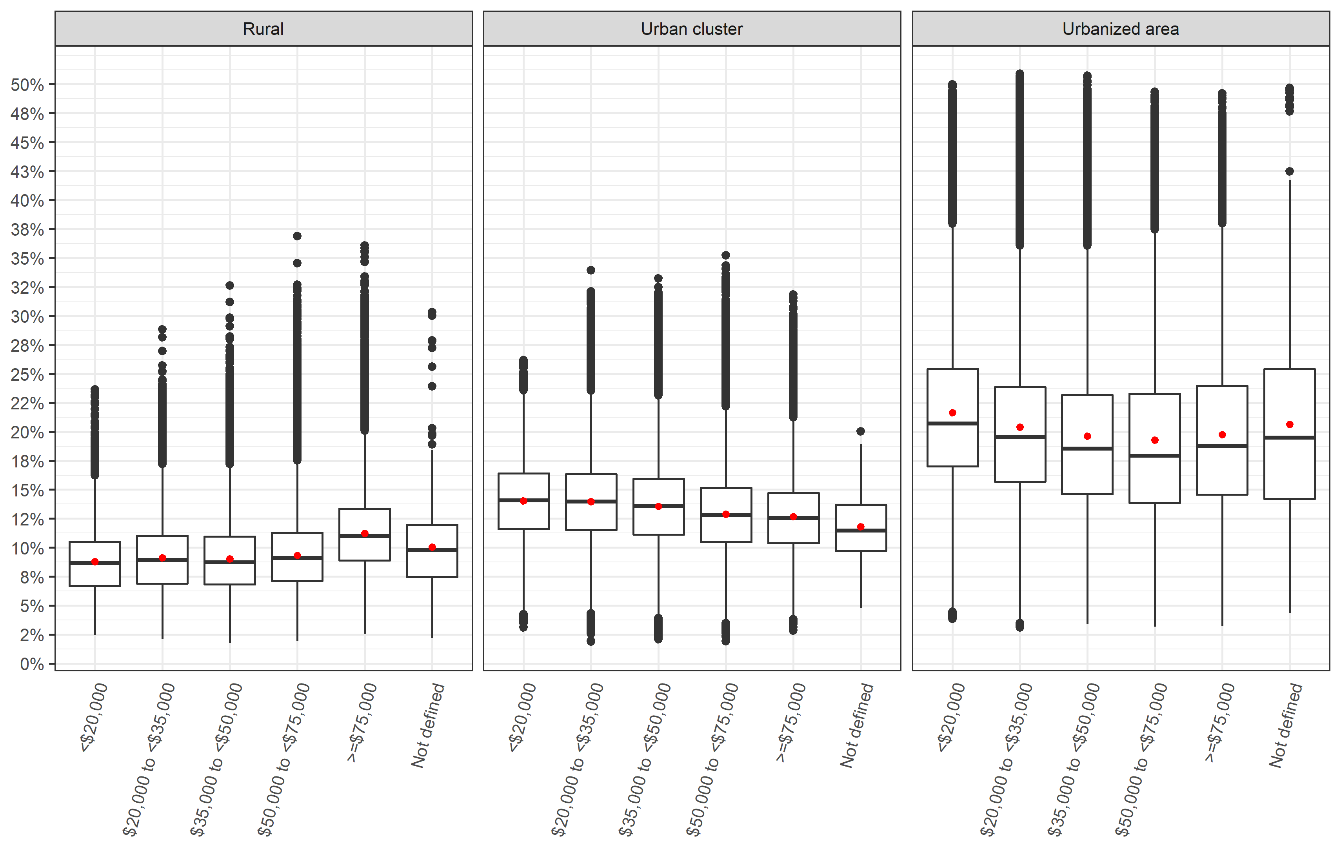

*\*Red dot represents the mean value while the midline represents the median value*

Figure 3: Attributable fraction by state

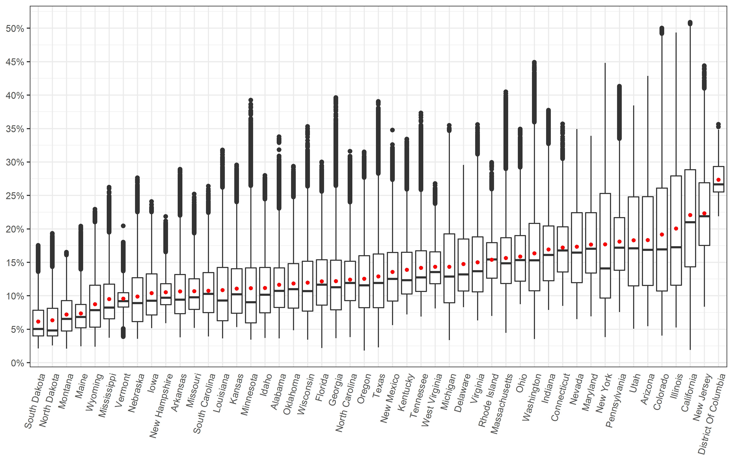

Figure 4: Attributable fraction by state and living location

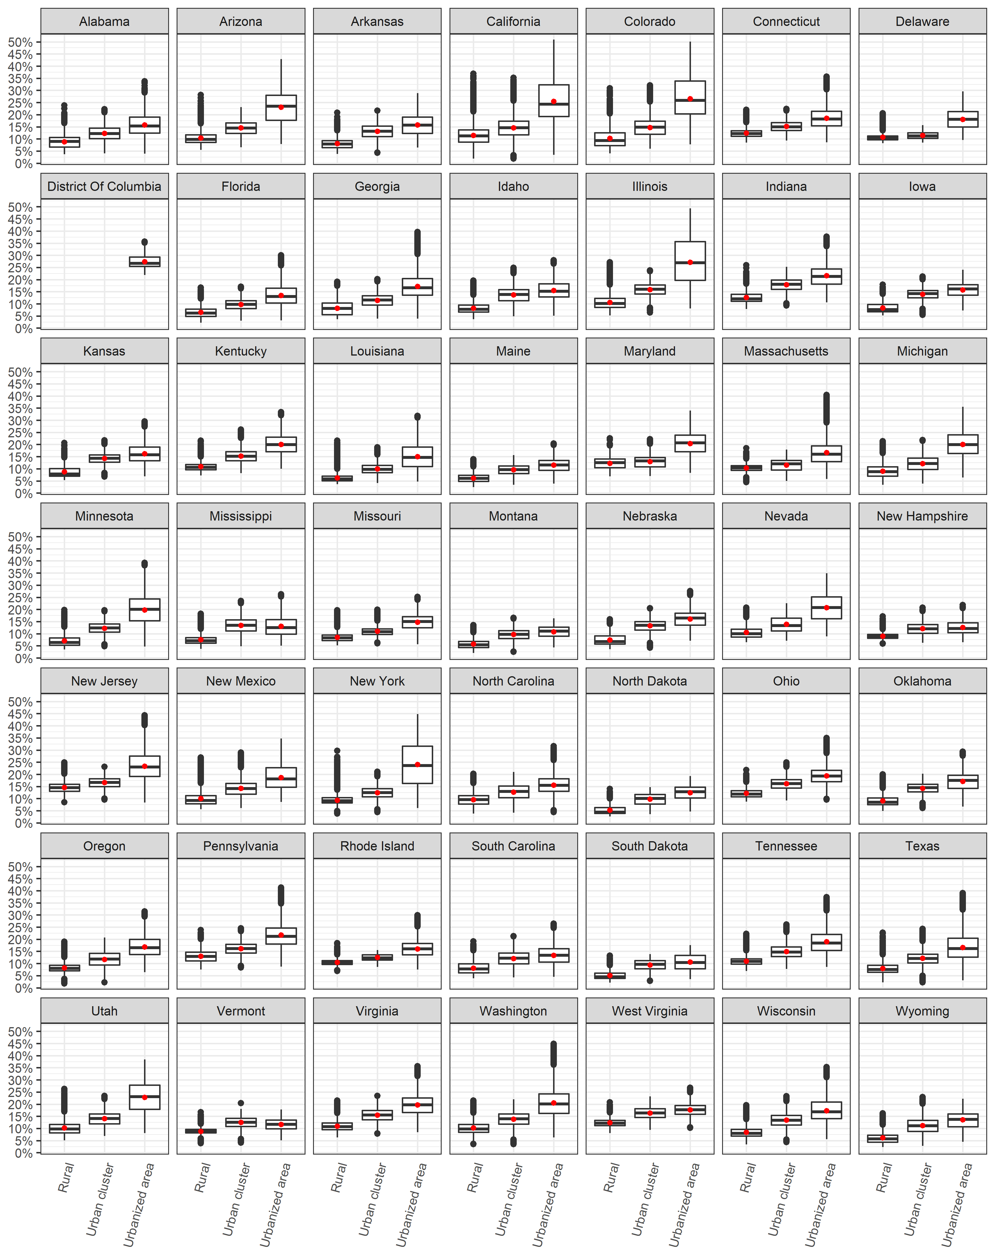

Figure 5: Attributable fraction by state and median income group

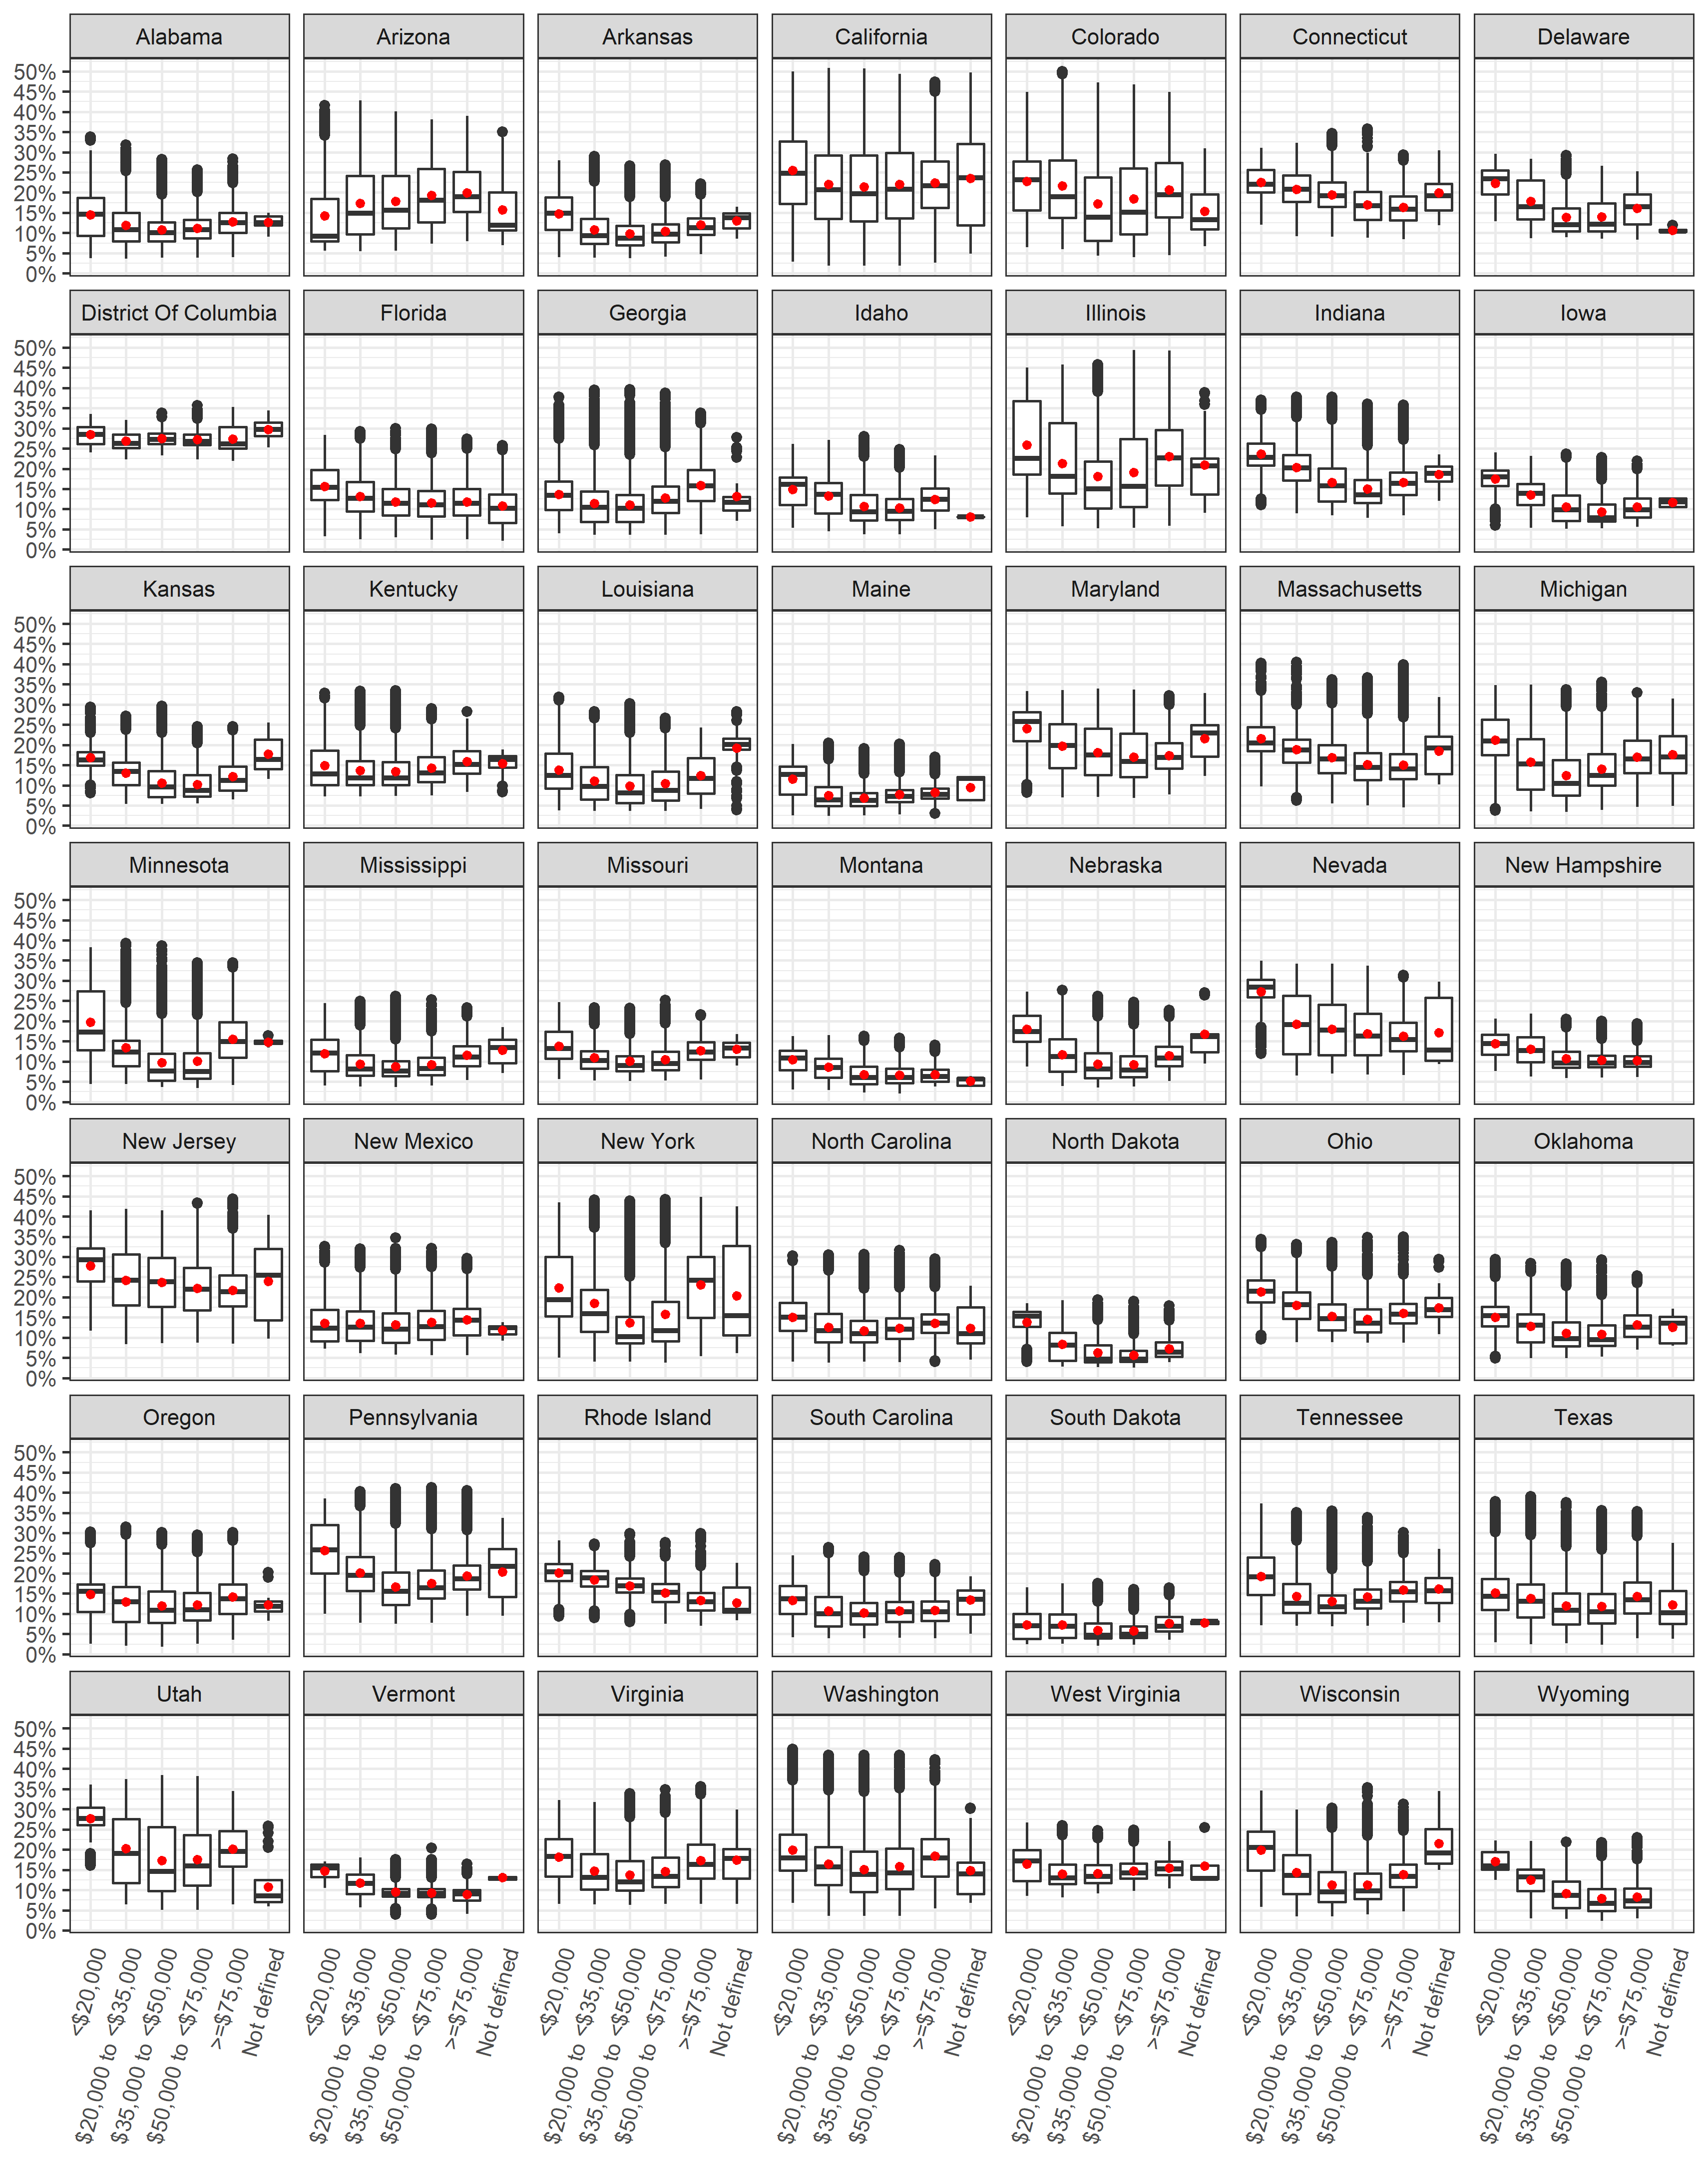

Achakulwisut, P., Brauer, M., Hystad, P., & Anenberg, S. C. (2019). Global, national, and urban burdens of paediatric asthma incidence attributable to ambient NO2 pollution: estimates from global datasets. *The Lancet Planetary Health, 3*(4), e166-e178.

Alotaibi, R., Bechle, M., Marshall, J. D., Ramani, T., Zietsman, J., Nieuwenhuijsen, M. J., & Khreis, H. (2019). Traffic related air pollution and the burden of childhood asthma in the contiguous United States in 2000 and 2010. *Environment international*.

Bechle, M. J., Millet, D. B., & Marshall, J. D. (2015). National spatiotemporal exposure surface for NO2: monthly scaling of a satellite-derived land-use regression, 2000–2010. *Environmental science & technology, 49*(20), 12297-12305.

Beelen, R., Hoek, G., Pebesma, E., Vienneau, D., de Hoogh, K., & Briggs, D. J. (2009). Mapping of background air pollution at a fine spatial scale across the European Union. *Science of the Total Environment, 407*(6), 1852-1867.

CDC. (2009). Centers for Disease Control and Prevention. Behavioral Risk Factor Surveillance System Survey Data. Atlanta, Georgia: U.S. Department of Health and Human Services, Centers for Disease Control and Prevention, 2019.

CDC. (2011). *Centers for Disease Control and Prevention. 2006-2008 ACBS Summary Data Qulaity Report. 2011*. Retrieved from <https://www.cdc.gov/brfss/acbs/2008> \_ documentation.htm

Clark, L. P., Millet, D. B., & Marshall, J. D. (2017). Changes in transportation-related air pollution exposures by race-ethnicity and socioeconomic status: Outdoor nitrogen dioxide in the United States in 2000 and 2010. *Environmental health perspectives, 125*(9), 1--10. doi:10.1289/EHP959

Garbe, P., Balluz, L. S., & Chief, B. (2011). Behavioral Risk Factor Surveillance System Asthma Call-Back Survey History And Analysis Guidance.

Hystad, P., Setton, E., Cervantes, A., Poplawski, K., Deschenes, S., Brauer, M., van Donkelaar, A., Lamsal, L., Martin, R., & Jerrett, M. (2011). Creating national air pollution models for population exposure assessment in Canada. *Environmental health perspectives, 119*(8), 1123.

Khreis, H., de Hoogh, K., & Nieuwenhuijsen, M. J. (2018). Full-chain health impact assessment of traffic-related air pollution and childhood asthma. *Environment international, 114*, 365-375.

Khreis, H., Kelly, C., Tate, J., Parslow, R., Lucas, K., & Nieuwenhuijsen, M. (2017). Exposure to traffic-related air pollution and risk of development of childhood asthma: a systematic review and meta-analysis. *Environment international, 100*, 1-31.

Khreis, H., Ramani, T., de Hoogh, K., Mueller, N., Rojas-Rueda, D., Zietsman, J., & Nieuwenhuijsen, M. J. (2018). Traffic-Related Air Pollution and the Local Burden of Childhood Asthma in Bradford, UK. *International Journal of Transportation Science and Technology*.

Khreis, H. C., Marta; Mueller, Natalie; Kees de Hoogh; Hoek, Gerard; Nieuwenhuijsen, Mark J; Rojas-Rueda, David;. (In prep). Outdoor Air Pollution and the Burden of Childhood Asthma across Europe. *European Respiratory Journal*.

Korn, E. L., & Graubard, B. I. (2011). *Analysis of health surveys* (Vol. 323): John Wiley & Sons.

Manson, S., Schroeder, J., Van Riper, D., & Ruggles, S. (2018). *IPUMS National Historical Geographic Information System: Version 13.0 [Database]. Minneapolis: University of Minnesota.*

Mausner, J., & Kramer, S. (1985). Epidemiology: An Introductory Text. Phila-delphia. *PA: Saunders*.

Novotny, E. V., Bechle, M. J., Millet, D. B., & Marshall, J. D. (2011). National satellite-based land-use regression: NO2 in the United States. *Environmental science & technology, 45*(10), 4407-4414.

Perez, L., Declercq, C., Iñiguez, C., Aguilera, I., Badaloni, C., Ballester, F., Bouland, C., Chanel, O., Cirarda, F. B., & Forastiere, F. (2013). Chronic burden of near-roadway traffic pollution in 10 European cities (APHEKOM network). *European Respiratory Journal*, erj00311-02012.

Perez, L., Künzli, N., Avol, E., Hricko, A. M., Lurmann, F., Nicholas, E., Gilliland, F., Peters, J., & McConnell, R. (2009). Global goods movement and the local burden of childhood asthma in southern California. *American Journal of Public Health, 99*(S3), S622-S628.

R Core Team. (2018). R: A Language and Environment for Statistical Computing: R Foundation for Statistical Computing. Retrieved from <https://www.R-project.org/>

US Census Bureau. (2010). American factfinder: US Census Bureau Washington, DC.

US Census Bureau. (2016, 2016, December 8

). Defining rural at the U.S. census bureau. Retrieved from <https://www.census.gov/library/publications/2016/acs/acsgeo-1.html>

Vienneau, D., De Hoogh, K., Bechle, M. J., Beelen, R., Van Donkelaar, A., Martin, R. V., Millet, D. B., Hoek, G., & Marshall, J. D. (2013). Western European land use regression incorporating satellite-and ground-based measurements of NO2 and PM10. *Environmental science & technology, 47*(23), 13555-13564.

WHO. (2005). *Air Quality Guidlines Global Update 2005*. Retrieved from <www.euro.who.int>

Winer, R. A., Qin, X., Harrington, T., Moorman, J., & Zahran, H. (2012). Asthma incidence among children and adults: findings from the Behavioral Risk Factor Surveillance system asthma call-back survey—United States, 2006–2008. *Journal of Asthma, 49*(1), 16-22.

**Supplementary Material**

Table S1: NO2 concentration (ug/m3) by state 19

Table S2: Available childhood asthma incidence rates by state and year 21

Table S3: Childhood asthma survey summary by state (Total of 2006-2010) 23

Table S4: State results and comparison 25

Table S5: Comparing results by state 27

Figure S1: NO2 concentration (ug/m3) by living location 29

Figure S2: NO2 concentration (ug/m3) by median income group 30

Figure S3: NO2 concentration (ug/m3) by living location stratified into median income group 30

Figure S4: NO2 concentration (ug/m3) by median income group stratified into living location 31

Figure S5: NO2 concentration (ug/m3) by state 31

Figure S6: NO2 concentration (ug/m3) by state and median income group 32

Figure S7: NO2 concentration (ug/m3) by state and living location 33

Figure S8: Attributable Fraction by living location 34

Figure S9: Attributable Fraction by median income group 34

Figure S10: Attributable Fraction by median income group stratified into living location 35

Table S1: NO2 concentration (ug/m3) by state

|  |  |  |  |  |  |  |
| --- | --- | --- | --- | --- | --- | --- |
| **State** | **Mean** | **Min** | **25%** | **Median** | **75%** | **Max** |
| Alabama | 10.3 | 3.0 | 7.1 | 9.3 | 12.5 | 33.8 |
| Arizona | 17.0 | 4.6 | 10.1 | 15.1 | 23.4 | 45.9 |
| Arkansas | 9.3 | 3.2 | 6.2 | 8.1 | 11.6 | 28.0 |
| California | 21.1 | 1.6 | 12.7 | 19.3 | 27.9 | 58.3 |
| Colorado | 18.1 | 3.4 | 9.3 | 15.2 | 24.8 | 56.9 |
| Connecticut | 15.6 | 7.3 | 11.9 | 15.0 | 18.6 | 36.2 |
| Delaware | 13.2 | 7.1 | 9.3 | 11.6 | 16.7 | 28.7 |
| District of Columbia | 26.3 | 20.2 | 24.2 | 25.4 | 28.5 | 36.1 |
| Florida | 10.7 | 1.8 | 7.4 | 10.2 | 13.7 | 29.2 |
| Georgia | 10.8 | 3.0 | 6.8 | 9.8 | 13.6 | 41.4 |
| Idaho | 9.8 | 3.1 | 6.4 | 8.8 | 12.6 | 26.9 |
| Illinois | 19.0 | 4.4 | 10.1 | 15.5 | 26.9 | 55.7 |
| Indiana | 15.4 | 6.7 | 10.7 | 14.4 | 18.7 | 38.9 |
| Iowa | 9.1 | 4.3 | 6.1 | 8.0 | 11.7 | 22.6 |
| Kansas | 9.7 | 4.5 | 6.3 | 8.8 | 12.4 | 28.7 |
| Kentucky | 12.4 | 6.1 | 8.9 | 10.8 | 14.8 | 33.3 |
| Louisiana | 9.6 | 3.0 | 5.3 | 8.0 | 12.6 | 31.4 |
| Maine | 6.3 | 2.0 | 4.4 | 5.8 | 7.5 | 18.7 |
| Maryland | 16.1 | 5.9 | 11.8 | 15.3 | 20.8 | 34.0 |
| Massachusetts | 14.1 | 3.7 | 10.3 | 13.2 | 17.0 | 42.5 |
| Michigan | 12.9 | 2.8 | 7.7 | 11.3 | 17.5 | 35.9 |
| Minnesota | 9.9 | 2.9 | 5.0 | 7.8 | 12.5 | 40.8 |
| Mississippi | 8.3 | 3.1 | 5.6 | 7.0 | 10.2 | 24.9 |
| Missouri | 9.3 | 4.4 | 6.8 | 8.4 | 11.0 | 23.8 |
| Montana | 6.2 | 1.7 | 4.0 | 5.5 | 8.0 | 14.8 |
| Nebraska | 8.6 | 3.0 | 5.2 | 7.7 | 11.1 | 26.5 |
| Nevada | 15.9 | 5.5 | 10.5 | 14.7 | 20.8 | 35.2 |
| New Hampshire | 9.1 | 5.0 | 7.4 | 8.4 | 10.3 | 20.2 |
| New Jersey | 21.0 | 7.1 | 15.8 | 20.2 | 25.7 | 48.1 |
| New Mexico | 12.1 | 4.7 | 7.9 | 11.0 | 14.8 | 35.0 |
| New York | 16.6 | 3.2 | 8.3 | 12.4 | 23.9 | 48.7 |
| North Carolina | 11.0 | 3.2 | 8.0 | 10.4 | 13.5 | 31.1 |
| North Dakota | 5.4 | 2.1 | 3.3 | 4.0 | 6.9 | 17.6 |
| Ohio | 14.3 | 7.5 | 10.7 | 13.6 | 17.3 | 35.2 |
| Oklahoma | 10.4 | 4.1 | 7.0 | 9.5 | 13.1 | 28.5 |
| Oregon | 11.1 | 1.5 | 7.0 | 10.1 | 14.3 | 31.0 |
| Pennsylvania | 16.6 | 6.4 | 12.2 | 15.5 | 20.1 | 43.7 |
| Rhode Island | 13.8 | 5.9 | 11.1 | 13.7 | 16.2 | 29.2 |
| South Carolina | 9.4 | 3.3 | 6.4 | 8.9 | 11.9 | 25.1 |
| South Dakota | 5.2 | 1.8 | 3.3 | 4.2 | 6.7 | 15.8 |
| Tennessee | 12.7 | 5.9 | 9.2 | 11.2 | 15.0 | 38.3 |
| Texas | 11.5 | 1.9 | 7.0 | 10.4 | 14.5 | 40.6 |
| Utah | 17.0 | 4.3 | 10.0 | 15.4 | 23.4 | 39.8 |
| Vermont | 8.3 | 3.3 | 7.1 | 7.9 | 9.1 | 18.7 |
| Virginia | 13.5 | 5.3 | 9.2 | 12.0 | 17.1 | 36.1 |
| Washington | 14.9 | 2.9 | 9.3 | 13.6 | 19.1 | 48.9 |
| West Virginia | 12.7 | 6.9 | 10.3 | 11.9 | 14.9 | 25.5 |
| Wisconsin | 10.6 | 2.8 | 6.6 | 9.3 | 13.5 | 35.7 |
| Wyoming | 7.6 | 2.0 | 4.5 | 6.7 | 10.1 | 21.4 |

Table S2: Available childhood asthma incidence rates by state and year

|  |  |  |  |  |  |  |
| --- | --- | --- | --- | --- | --- | --- |
| **State** | **2006\*** | **2007\*** | **2008\*** | **2009\*** | **2010\*** | **Aggregate IR\*** |
| Alabama |  |  |  |  |  |  |
| Alaska |  |  |  |  |  |  |
| Arizona | 23.7 | 6.8 |  |  |  | 15.2 |
| Arkansas |  |  |  |  |  |  |
| California | 12.1 | 6.5 |  |  |  | 9.3 |
| Colorado |  |  |  |  |  |  |
| Connecticut |  | 9.9 | 14.1 | 10.8 | 13.5 | 12.0 |
| Delaware |  |  |  |  |  |  |
| District of Columbia | 5.3 | 28.8 |  |  |  | 17.7 |
| Florida |  |  |  |  |  |  |
| Georgia | 6.4 | 5.8 | 9.1 | 16.6 | 6.9 | 9.1 |
| Hawaii |  |  |  |  |  |  |
| Idaho |  |  |  |  |  |  |
| Illinois |  | 4.2 |  | 9.2 |  | 6.7 |
| Indiana | 25.4 | 9.3 | 13.4 | 9.9 | 17.6 | 15.2 |
| Iowa | 5.0 | 4.0 | 9.9 |  |  | 6.3 |
| Kansas | 7.8 | 9.9 | 9.9 | 8.3 | 9.0 | 9.0 |
| Kentucky |  |  |  |  |  |  |
| Louisiana |  |  |  | 5.8 |  | 5.8 |
| Maine | 13.0 | 8.7 | 5.8 |  |  | 9.2 |
| Maryland | 16.2 | 8.6 | 11.0 | 17.3 | 2.3 | 11.2 |
| Massachusetts |  |  |  |  |  |  |
| Michigan | 5.3 | 7.7 | 5.2 | 13.4 | 29.3 | 12.0 |
| Minnesota |  |  |  |  |  |  |
| Mississippi |  | 10.8 |  |  | 17.2 | 14.0 |
| Missouri | 21.2 | 10.3 | 7.2 |  |  | 12.9 |
| Montana | 2.8 | 2.0 |  | 3.7 | 8.5 | 4.3 |
| Nebraska | 11.9 | 8.3 | 8.9 | 3.3 | 12.9 | 9.1 |
| Nevada |  |  |  |  |  |  |
| New Hampshire | 11.5 | 13.8 | 10.4 |  |  | 12.0 |
| New Jersey |  |  | 6.3 | 12.5 | 10.5 | 9.8 |
| New Mexico |  | 3.2 | 9.5 |  | 7.2 | 6.7 |
| New York | 12.9 | 6.1 | 28.4 | 11.2 |  | 14.7 |
| North Carolina |  |  |  |  |  |  |
| North Dakota |  |  |  |  |  |  |
| Ohio |  | 13.1 | 17.0 |  |  | 15.1 |
| Oklahoma |  | 9.2 | 10.1 |  | 12.9 | 10.8 |
| Oregon |  | 11.1 |  |  |  | 11.1 |
| Pennsylvania |  | 21.8 |  |  | 4.3 | 13.2 |
| Rhode Island |  |  | 15.3 | 13.2 |  | 14.3 |
| South Carolina |  |  |  |  |  |  |
| South Dakota |  |  |  |  |  |  |
| Tennessee |  |  |  |  |  |  |
| Texas | 14.4 |  | 18.2 | 12.5 | 21.0 | 16.6 |
| Utah |  | 15.4 | 11.9 | 5.6 | 9.3 | 10.4 |
| Vermont | 13.5 | 4.4 | 8.5 | 21.2 | 10.4 | 11.5 |
| Virginia |  |  |  |  |  |  |
| Washington |  |  |  | 7.9 | 5.6 | 6.8 |
| West Virginia |  | 11.8 |  |  |  | 11.8 |
| Wisconsin | 12.3 |  |  |  |  | 12.3 |
| Wyoming |  |  |  |  |  |  |

\**Incidence rate* per 1,000 at-risk children

Table S3: Childhood asthma survey summary by state (Total of 2006-2010)

|  |  |  |  |  |
| --- | --- | --- | --- | --- |
| **State** | **Total ACBS sample** | **Total BRFSS sample** | **Total ever asthma** | **Total incident case** |
| Arizona | 103 | 5,535 | 699 | 10 |
| California | 172 | 11,801 | 1,543 | 13 |
| Connecticut | 549 | 7,112 | 1,132 | 47 |
| D.C. | 69 | 4,101 | 685 | 6 |
| Georgia | 545 | 9,433 | 1,455 | 26 |
| Illinois | 122 | 6,187 | 778 | 6 |
| Indiana | 500 | 9,824 | 1,361 | 41 |
| Iowa | 245 | 8,084 | 724 | 19 |
| Kansas | 827 | 14,699 | 1,839 | 50 |
| Louisiana | 88 | 8,829 | 1,214 | 4 |
| Maine | 376 | 4,523 | 644 | 23 |
| Maryland | 624 | 13,093 | 1,897 | 44 |
| Michigan | 680 | 10,762 | 1,524 | 43 |
| Mississippi | 208 | 10,816 | 1,527 | 14 |
| Missouri | 262 | 5,646 | 814 | 20 |
| Montana | 286 | 8,609 | 909 | 17 |
| Nebraska | 717 | 17,883 | 1,644 | 53 |
| New Hampshire | 232 | 5,285 | 664 | 19 |
| New Jersey | 458 | 15,410 | 2,230 | 32 |
| New Mexico | 287 | 5,554 | 765 | 17 |
| New York | 404 | 7,083 | 1,079 | 28 |
| Ohio | 351 | 7,989 | 1,138 | 32 |
| Oklahoma | 299 | 8,611 | 1,291 | 21 |
| Oregon | 165 | 4,793 | 579 | 13 |
| Pennsylvania | 209 | 14,760 | 2,090 | 12 |
| Rhode Island | 169 | 7,127 | 1,209 | 11 |
| Texas | 780 | 16,749 | 2,293 | 55 |
| Utah | 573 | 14,417 | 1,617 | 45 |
| Vermont | 597 | 8,784 | 1,220 | 40 |
| Washington | 594 | 9,706 | 1,165 | 33 |
| West Virginia | 85 | 5,089 | 663 | 5 |
| Wisconsin | 140 | 5,170 | 611 | 10 |

\**Incidence rate* per 1,000 at-risk children

\**Prevalence rate per 100 child*

Table S4: State results and comparison

|  |  |  |  |  |  |  |  |  |  |
| --- | --- | --- | --- | --- | --- | --- | --- | --- | --- |
|  | **Main results** | | | | **Comparison** | | **Difference** | | |
| **State** | **Total children** | **Incident cases** | **AC** | **AF** | **Origin cases** | **Origin AC** | **Incident cases** | **AC** | **%** |
| **Alabama** | 1,132,459 | 11,700 | 1,380 | 11.8% | 12,216 | 1,439 | -494 | -58 (-4.0%) | -4.0% |
| **Arizona** | 1,629,014 | 21,500 | 4,620 | 21.5% | 17,573 | 3,772 | 3,965 | 851 (22.6%) | 22.6% |
| **Arkansas** | 711,475 | 7,500 | 860 | 11.6% | 7,675 | 887 | -199 | -23 (-2.6%) | -2.6% |
| **California** | 9,295,040 | 75,800 | 19,200 | 25.3% | 100,270 | 25,395 | -24,442 | -6,190 (-24.4%) | -24.4% |
| **Colorado** | 1,225,609 | 12,900 | 3,010 | 23.4% | 13,221 | 3,089 | -342 | -80 (-2.6%) | -2.6% |
| **Connecticut** | 817,015 | 8,300 | 1,500 | 18.2% | 8,814 | 1,601 | -549 | -100 (-6.2%) | -6.2% |
| **Delaware** | 205,765 | 2,000 | 330 | 16.0% | 2,220 | 355 | -184 | -29 (-8.3%) | -8.3% |
| **D.C.** | 100,815 | 1,400 | 390 | 26.9% | 1,088 | 293 | 346 | 93 (31.8%) | 31.8% |
| **Florida** | 4,002,091 | 42,100 | 5,360 | 12.7% | 43,173 | 5,502 | -1,118 | -142 (-2.6%) | -2.6% |
| **Georgia** | 2,491,552 | 19,200 | 2,770 | 14.5% | 26,878 | 3,887 | -7,713 | -1,115 (-28.7%) | -28.7% |
| **Idaho** | 429,072 | 4,700 | 590 | 12.6% | 4,629 | 581 | 96 | 12 (2.1%) | 2.1% |
| **Illinois** | 3,129,179 | 18,300 | 4,510 | 24.7% | 33,756 | 8,333 | -15,492 | -3,824 (-45.9%) | -45.9% |
| **Indiana** | 1,608,298 | 21,300 | 3,850 | 18.1% | 17,350 | 3,143 | 3,913 | 709 (22.6%) | 22.6% |
| **Iowa** | 727,993 | 4,200 | 520 | 12.4% | 7,853 | 971 | -3,660 | -453 (-46.6%) | -46.6% |
| **Kansas** | 726,939 | 5,800 | 790 | 13.6% | 7,842 | 1,067 | -2,061 | -281 (-26.3%) | -26.3% |
| **Kentucky** | 1,023,371 | 10,700 | 1,590 | 14.9% | 11,040 | 1,649 | -389 | -58 (-3.5%) | -3.5% |
| **Louisiana** | 1,118,015 | 5,600 | 650 | 11.6% | 12,061 | 1,401 | -6,445 | -749 (-53.4%) | -53.4% |
| **Maine** | 274,533 | 2,200 | 170 | 7.9% | 2,962 | 234 | -766 | -60 (-25.9%) | -25.9% |
| **Maryland** | 1,352,964 | 12,800 | 2,450 | 19.1% | 14,595 | 2,787 | -1,746 | -333 (-12.0%) | -12.0% |
| **Massachusetts** | 1,418,923 | 14,900 | 2,470 | 16.6% | 15,307 | 2,539 | -396 | -66 (-2.6%) | -2.6% |
| **Michigan** | 2,344,068 | 24,400 | 4,060 | 16.7% | 25,287 | 4,211 | -931 | -155 (-3.7%) | -3.7% |
| **Minnesota** | 1,284,063 | 14,100 | 2,120 | 15.1% | 13,852 | 2,093 | 210 | 32 (1.5%) | 1.5% |
| **Mississippi** | 755,555 | 9,100 | 930 | 10.2% | 8,151 | 832 | 951 | 97 (11.7%) | 11.7% |
| **Missouri** | 1,425,436 | 15,800 | 1,900 | 12.0% | 15,377 | 1,845 | 445 | 53 (2.9%) | 2.9% |
| **Montana** | 223,563 | 900 | 70 | 8.0% | 2,412 | 192 | -1,546 | -123 (-64.1%) | -64.1% |
| **Nebraska** | 459,221 | 3,800 | 490 | 13.1% | 4,954 | 648 | -1,179 | -154 (-23.8%) | -23.8% |
| **Nevada** | 665,008 | 7,200 | 1,430 | 19.9% | 7,174 | 1,431 | -4 | -1 (-0.1%) | -0.1% |
| **New Hampshire** | 287,234 | 3,000 | 330 | 10.9% | 3,099 | 338 | -82 | -9 (-2.6%) | -2.6% |
| **New Jersey** | 2,065,214 | 17,300 | 4,160 | 24.0% | 22,278 | 5,357 | -4,997 | -1,202 (-22.4%) | -22.4% |
| **New Mexico** | 518,672 | 3,000 | 470 | 15.4% | 5,595 | 864 | -2,548 | -394 (-45.5%) | -45.5% |
| **New York** | 4,324,929 | 53,600 | 13,500 | 25.2% | 46,655 | 11,754 | 6,945 | 1,750 (14.9%) | 14.9% |
| **North Carolina** | 2,281,635 | 24,000 | 3,100 | 12.9% | 24,613 | 3,182 | -637 | -82 (-2.6%) | -2.6% |
| **North Dakota** | 149,871 | 1,700 | 140 | 8.6% | 1,617 | 139 | 36 | 3 (2.2%) | 2.2% |
| **Ohio** | 2,730,751 | 36,100 | 6,160 | 17.1% | 29,458 | 5,036 | 6,602 | 1,129 (22.4%) | 22.4% |
| **Oklahoma** | 929,666 | 8,600 | 1,150 | 13.4% | 10,029 | 1,342 | -1,410 | -189 (-14.1%) | -14.1% |
| **Oregon** | 866,453 | 8,500 | 1,180 | 13.9% | 9,347 | 1,295 | -829 | -115 (-8.9%) | -8.9% |
| **Pennsylvania** | 2,792,155 | 31,600 | 6,310 | 20.0% | 30,120 | 6,011 | 1,499 | 299 (5.0%) | 5.0% |
| **Rhode Island** | 223,956 | 2,700 | 420 | 15.7% | 2,416 | 380 | 263 | 41 (10.9%) | 10.9% |
| **South Carolina** | 1,080,474 | 11,400 | 1,250 | 11.0% | 11,656 | 1,287 | -302 | -33 (-2.6%) | -2.6% |
| **South Dakota** | 202,797 | 2,100 | 160 | 7.6% | 2,188 | 165 | -57 | -4 (-2.6%) | -2.6% |
| **Tennessee** | 1,496,001 | 15,700 | 2,440 | 15.5% | 16,138 | 2,503 | -418 | -65 (-2.6%) | -2.6% |
| **Texas** | 6,865,824 | 99,100 | 14,320 | 14.4% | 74,065 | 10,701 | 25,019 | 3,615 (33.8%) | 33.8% |
| **Utah** | 871,027 | 8,100 | 1,670 | 20.5% | 9,396 | 1,929 | -1,254 | -258 (-13.3%) | -13.3% |
| **Vermont** | 129,233 | 1,300 | 130 | 9.8% | 1,394 | 136 | -110 | -11 (-7.9%) | -7.9% |
| **Virginia** | 1,853,677 | 19,400 | 3,320 | 17.2% | 19,997 | 3,430 | -622 | -107 (-3.1%) | -3.1% |
| **Washington** | 1,581,354 | 9,600 | 1,700 | 17.8% | 17,059 | 3,039 | -7,500 | -1,336 (-44.0%) | -44.0% |
| **West Virginia** | 387,418 | 4,000 | 580 | 14.4% | 4,179 | 603 | -176 | -25 (-4.2%) | -4.2% |
| **Wisconsin** | 1,339,492 | 14,700 | 2,150 | 14.7% | 14,450 | 2,118 | 244 | 36 (1.7%) | 1.7% |
| **Wyoming** | 135,402 | 1,500 | 140 | 9.7% | 1,461 | 141 | 22 | 2 (1.5%) | 1.5% |

Table S5: Comparing results by state

|  |  |  |  |  |  |  |  |  |
| --- | --- | --- | --- | --- | --- | --- | --- | --- |
| **State** | **State cases** | **Origin cases** | **Diff** | **% Diff** | **State AC** | **Origin AC** | **Diff** | **% Diff** |
| Montana | 866 | 2,412 | -1,546 | -64.1% | 69 | 192 | -123 | -64.1% |
| Louisiana | 5,616 | 12,061 | -6,445 | -53.4% | 653 | 1,401 | -749 | -53.4% |
| Iowa | 4,193 | 7,853 | -3,660 | -46.6% | 519 | 971 | -453 | -46.6% |
| Illinois | 18,264 | 33,756 | -15,492 | -45.9% | 4,509 | 8,333 | -3,824 | -45.9% |
| New Mexico | 3,047 | 5,595 | -2,548 | -45.5% | 471 | 864 | -394 | -45.5% |
| Washington | 9,559 | 17,059 | -7,500 | -44.0% | 1,703 | 3,039 | -1,336 | -44.0% |
| Georgia | 19,165 | 26,878 | -7,713 | -28.7% | 2,772 | 3,887 | -1,115 | -28.7% |
| Kansas | 5,781 | 7,842 | -2,061 | -26.3% | 787 | 1,067 | -281 | -26.3% |
| Maine | 2,196 | 2,962 | -766 | -25.9% | 173 | 234 | -60 | -25.9% |
| California | 75,829 | 100,270 | -24,442 | -24.4% | 19,205 | 25,395 | -6,190 | -24.4% |
| Nebraska | 3,775 | 4,954 | -1,179 | -23.8% | 494 | 648 | -154 | -23.8% |
| New Jersey | 17,281 | 22,278 | -4,997 | -22.4% | 4,155 | 5,357 | -1,202 | -22.4% |
| Oklahoma | 8,619 | 10,029 | -1,410 | -14.1% | 1,154 | 1,342 | -189 | -14.1% |
| Utah | 8,142 | 9,396 | -1,254 | -13.3% | 1,672 | 1,929 | -258 | -13.3% |
| Maryland | 12,849 | 14,595 | -1,746 | -12.0% | 2,454 | 2,787 | -333 | -12.0% |
| Oregon | 8,517 | 9,347 | -829 | -8.9% | 1,180 | 1,295 | -115 | -8.9% |
| Delaware | 2,036 | 2,220 | -184 | -8.3% | 326 | 355 | -29 | -8.3% |
| Vermont | 1,285 | 1,394 | -110 | -7.9% | 126 | 136 | -11 | -7.9% |
| Connecticut | 8,265 | 8,814 | -549 | -6.2% | 1,502 | 1,601 | -100 | -6.2% |
| West Virginia | 4,003 | 4,179 | -176 | -4.2% | 578 | 603 | -25 | -4.2% |
| Alabama | 11,722 | 12,216 | -494 | -4.0% | 1,381 | 1,439 | -58 | -4.0% |
| Michigan | 24,356 | 25,287 | -931 | -3.7% | 4,056 | 4,211 | -155 | -3.7% |
| Kentucky | 10,650 | 11,040 | -389 | -3.5% | 1,591 | 1,649 | -58 | -3.5% |
| Virginia | 19,375 | 19,997 | -622 | -3.1% | 3,323 | 3,430 | -107 | -3.1% |
| New Hampshire | 3,017 | 3,099 | -82 | -2.6% | 329 | 338 | -9 | -2.6% |
| Arkansas | 7,476 | 7,675 | -199 | -2.6% | 864 | 887 | -23 | -2.6% |
| Massachusetts | 14,910 | 15,307 | -396 | -2.6% | 2,473 | 2,539 | -66 | -2.6% |
| South Carolina | 11,354 | 11,656 | -302 | -2.6% | 1,254 | 1,287 | -33 | -2.6% |
| Tennessee | 15,720 | 16,138 | -418 | -2.6% | 2,438 | 2,503 | -65 | -2.6% |
| South Dakota | 2,131 | 2,188 | -57 | -2.6% | 161 | 165 | -4 | -2.6% |
| Colorado | 12,879 | 13,221 | -342 | -2.6% | 3,009 | 3,089 | -80 | -2.6% |
| North Carolina | 23,976 | 24,613 | -637 | -2.6% | 3,099 | 3,182 | -82 | -2.6% |
| Florida | 42,055 | 43,173 | -1,118 | -2.6% | 5,360 | 5,502 | -142 | -2.6% |
| Nevada | 7,170 | 7,174 | -4 | -0.1% | 1,430 | 1,431 | -1 | -0.1% |
| Wyoming | 1,482 | 1,461 | 22 | 1.5% | 144 | 141 | 2 | 1.5% |
| Minnesota | 14,061 | 13,852 | 210 | 1.5% | 2,124 | 2,093 | 32 | 1.5% |
| Wisconsin | 14,694 | 14,450 | 244 | 1.7% | 2,154 | 2,118 | 36 | 1.7% |
| Idaho | 4,724 | 4,629 | 96 | 2.1% | 593 | 581 | 12 | 2.1% |
| North Dakota | 1,652 | 1,617 | 36 | 2.2% | 142 | 139 | 3 | 2.2% |
| Missouri | 15,821 | 15,377 | 445 | 2.9% | 1,898 | 1,845 | 53 | 2.9% |
| Pennsylvania | 31,619 | 30,120 | 1,499 | 5.0% | 6,310 | 6,011 | 299 | 5.0% |
| Rhode Island | 2,679 | 2,416 | 263 | 10.9% | 422 | 380 | 41 | 10.9% |
| Mississippi | 9,101 | 8,151 | 951 | 11.7% | 929 | 832 | 97 | 11.7% |
| New York | 53,600 | 46,655 | 6,945 | 14.9% | 13,504 | 11,754 | 1,750 | 14.9% |
| Ohio | 36,060 | 29,458 | 6,602 | 22.4% | 6,165 | 5,036 | 1,129 | 22.4% |
| Indiana | 21,263 | 17,350 | 3,913 | 22.6% | 3,852 | 3,143 | 709 | 22.6% |
| Arizona | 21,538 | 17,573 | 3,965 | 22.6% | 4,623 | 3,772 | 851 | 22.6% |
| D.C. | 1,433 | 1,088 | 346 | 31.8% | 386 | 293 | 93 | 31.8% |
| Texas | 99,084 | 74,065 | 25,019 | 33.8% | 14,316 | 10,701 | 3,615 | 33.8% |

Figure S1: NO2 concentration (ug/m3) by living location

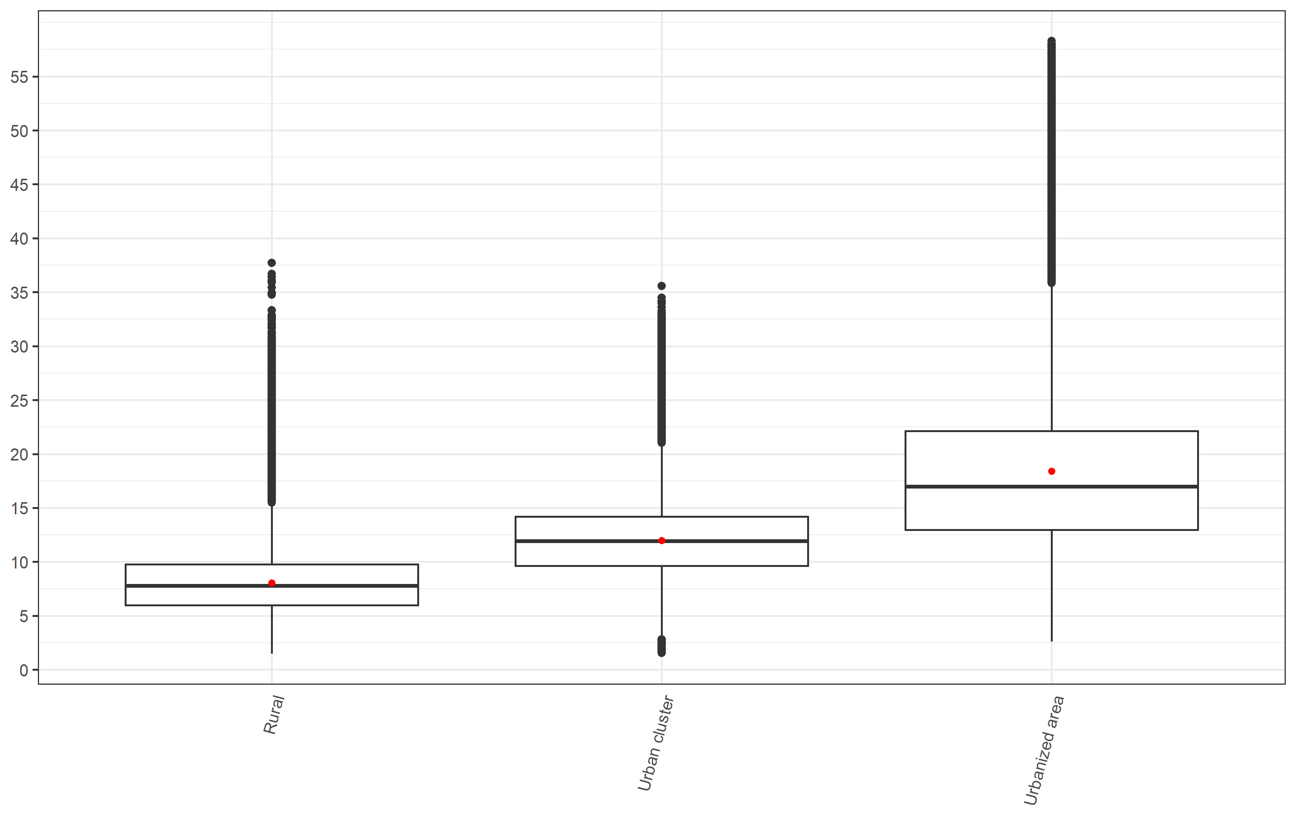

*\*Red dot represents the mean value while the midline represents the median value*

Figure S2: NO2 concentration (ug/m3) by median income group

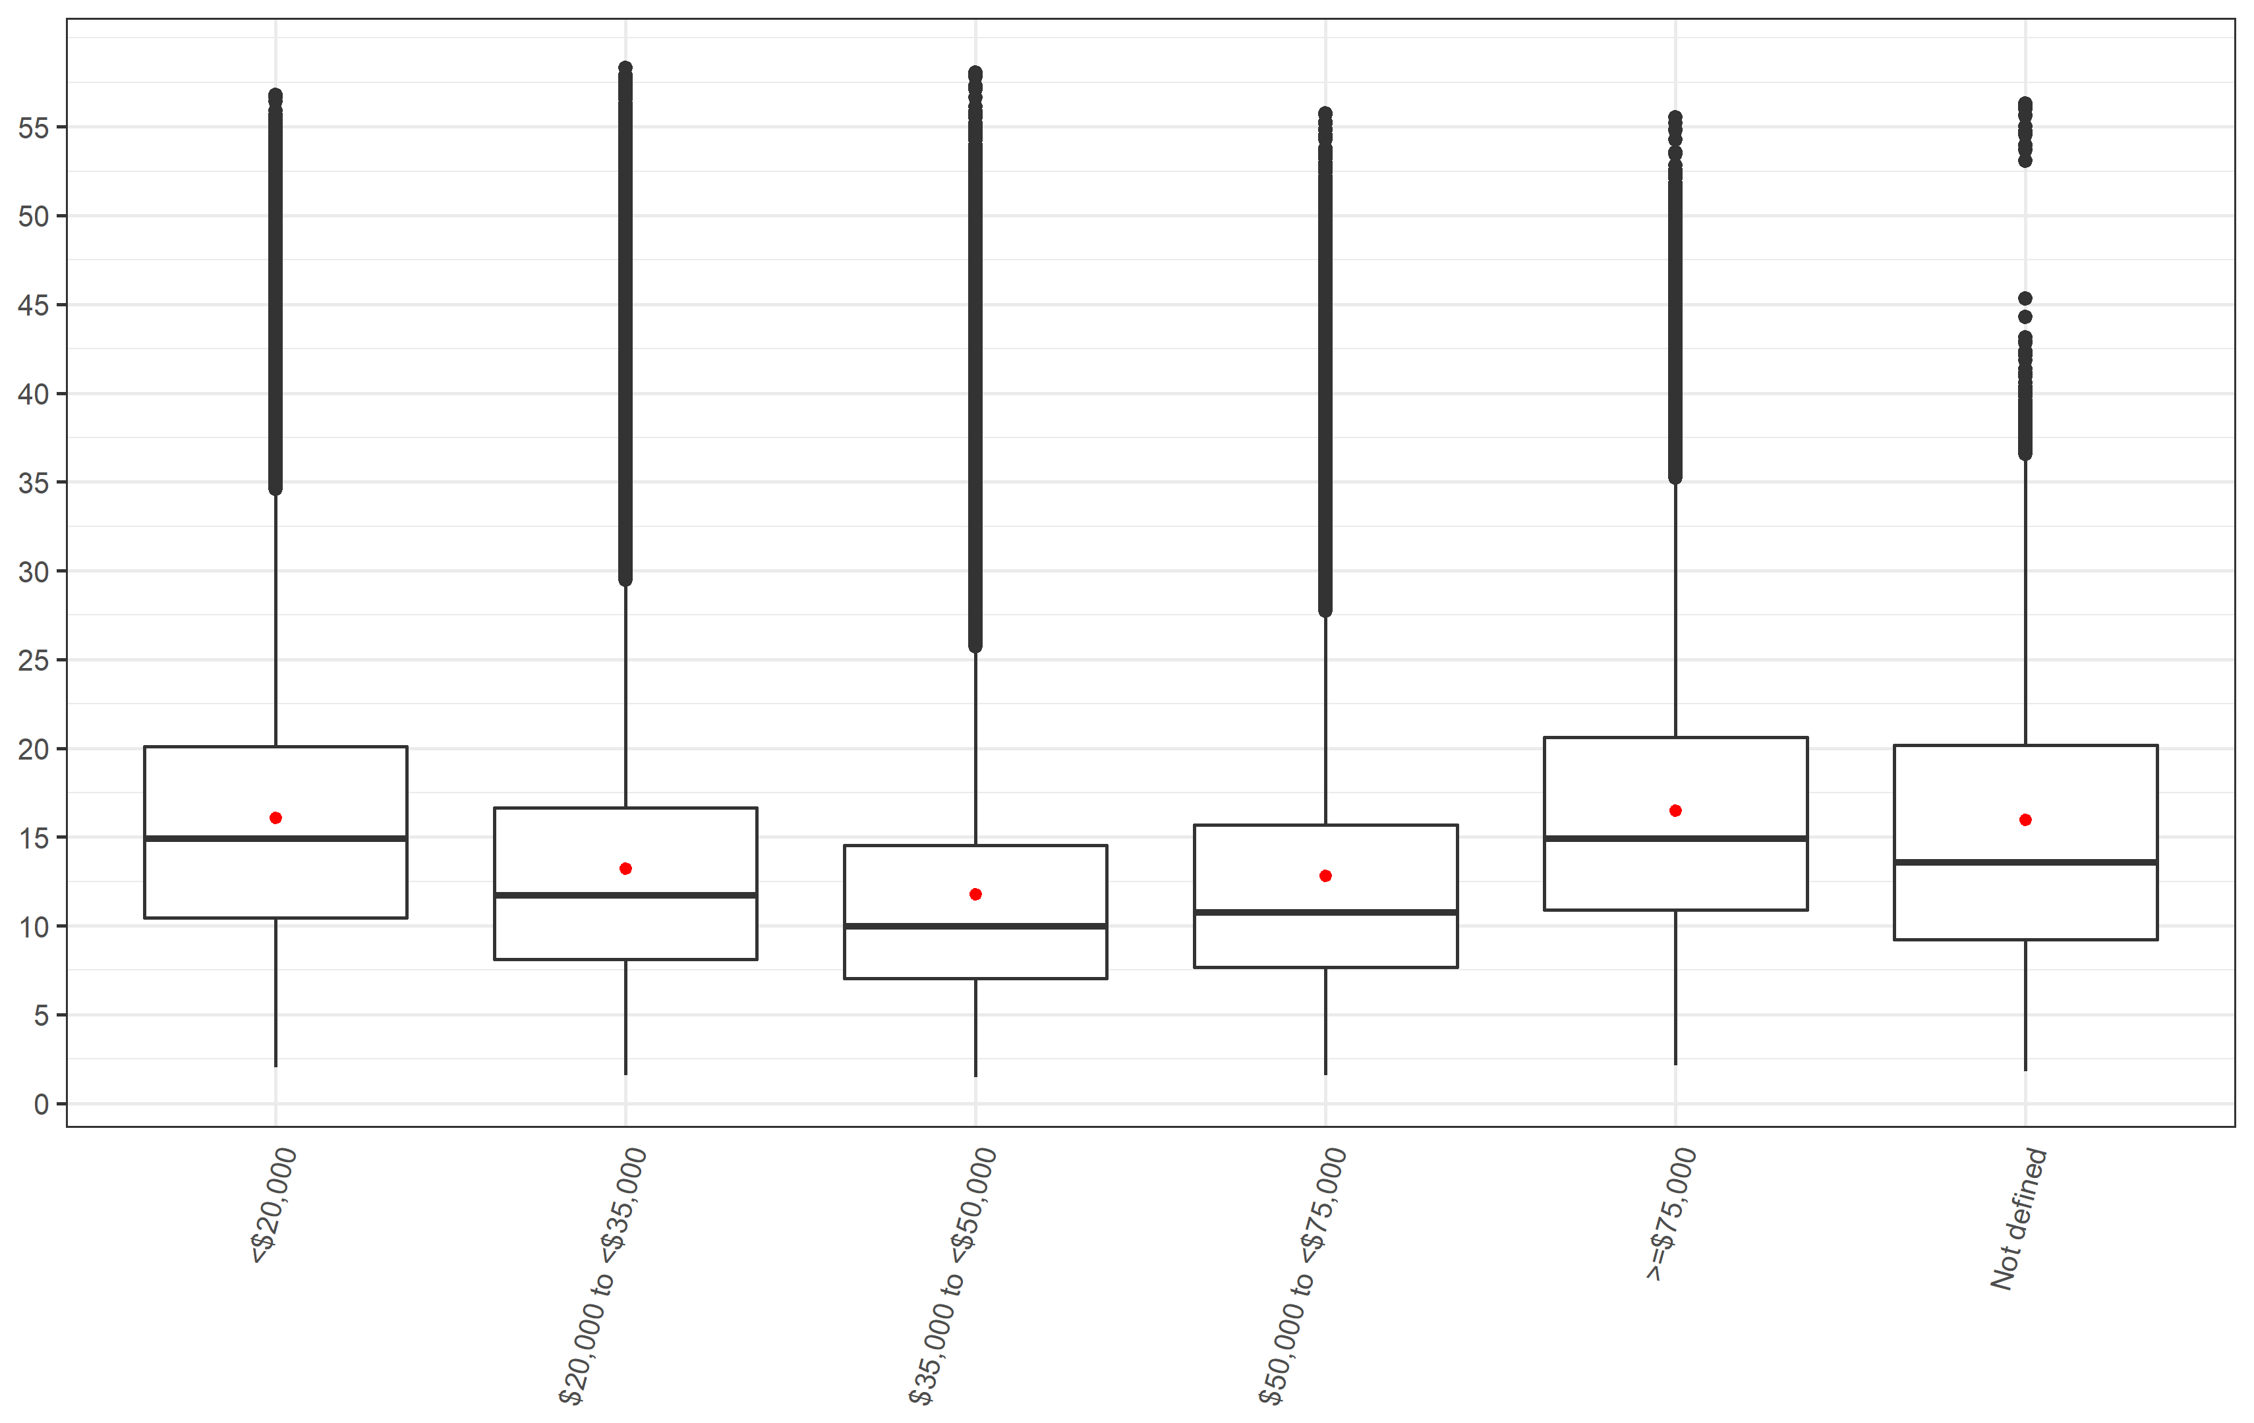

Figure S3: NO2 concentration (ug/m3) by living location stratified into median income group

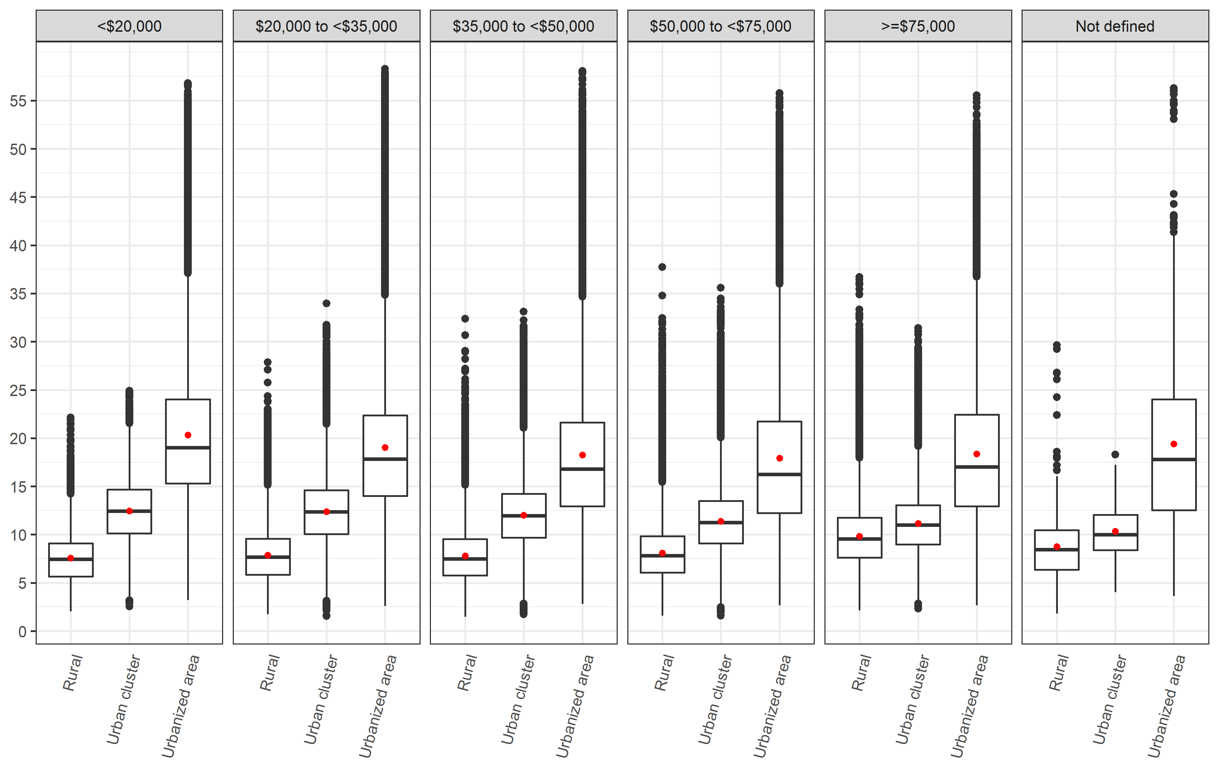

Figure S4: NO2 concentration (ug/m3) by median income group stratified into living location

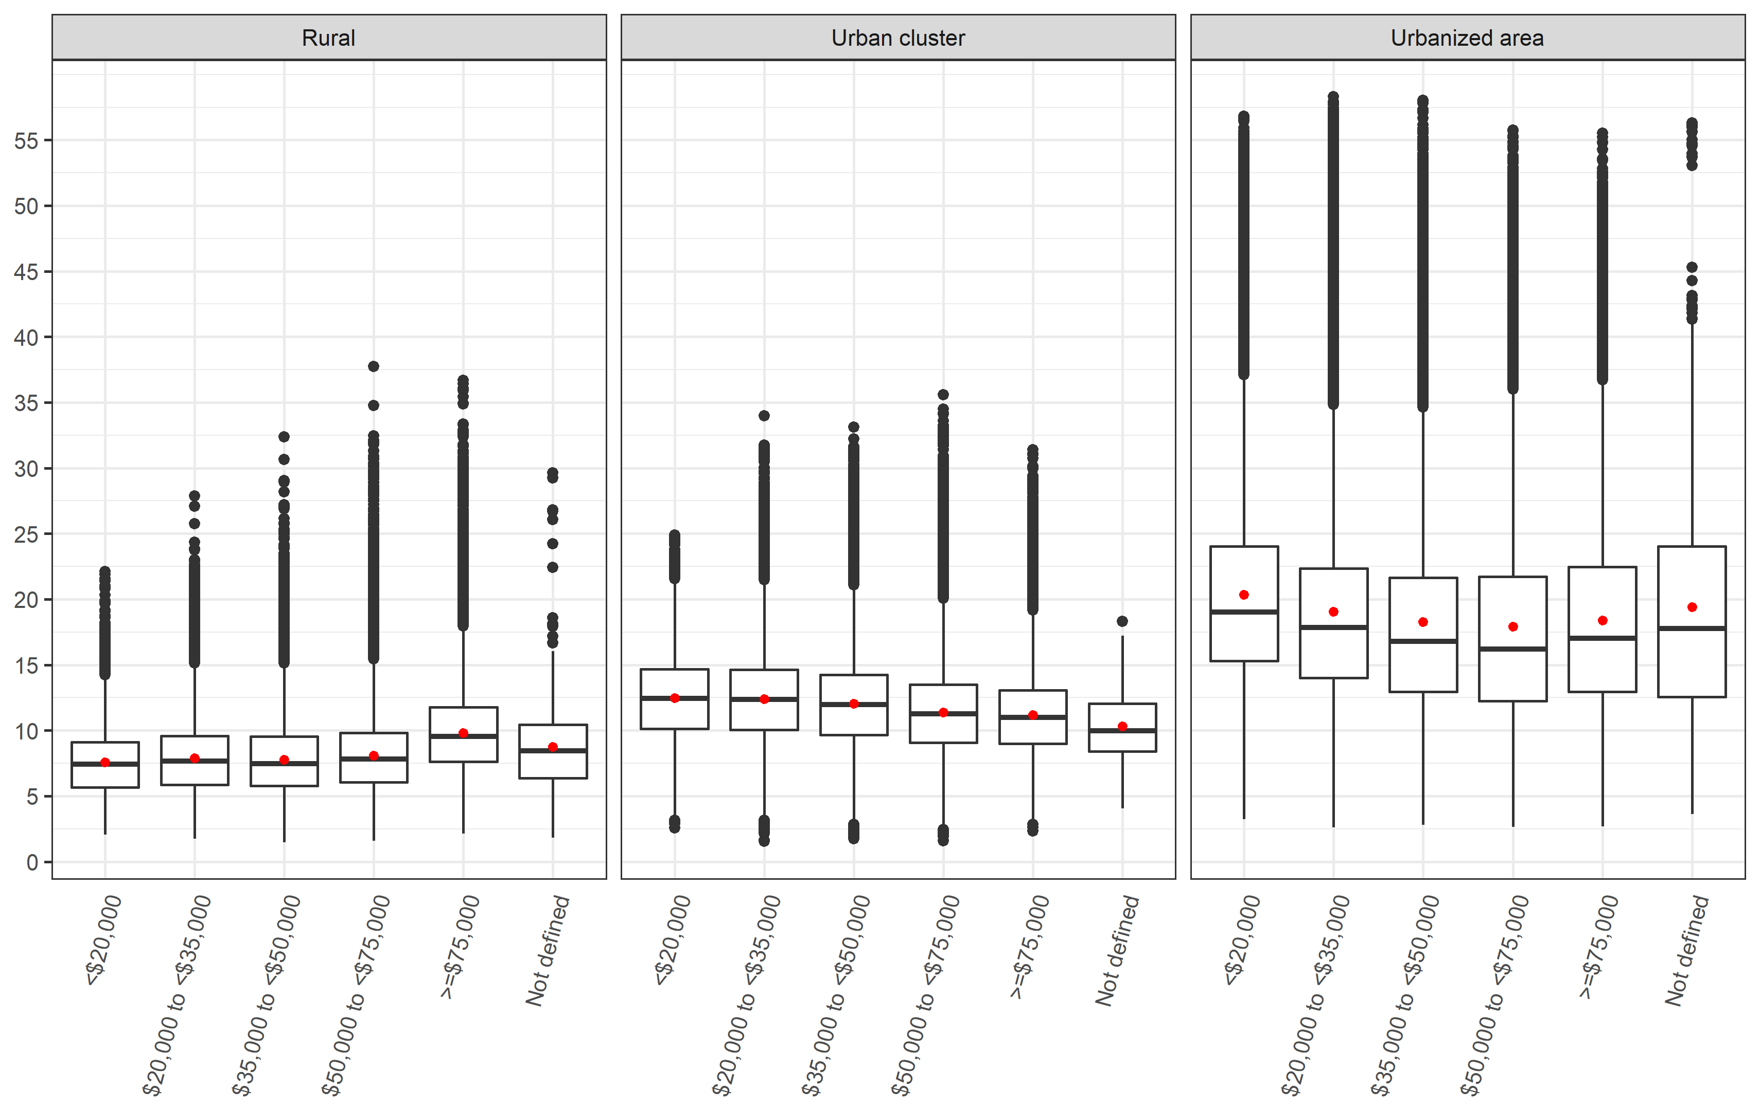

Figure S5: NO2 concentration (ug/m3) by state

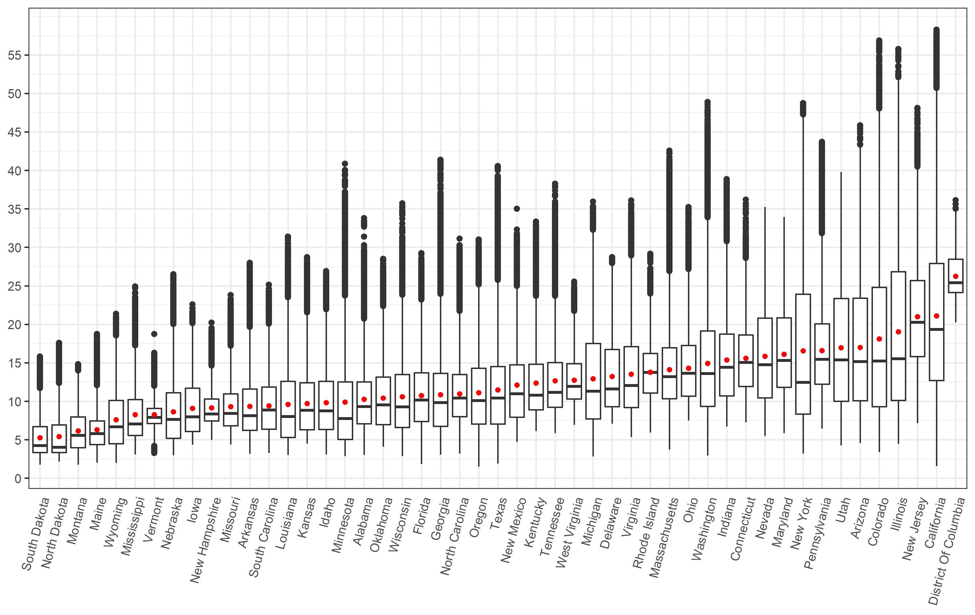

Figure S6: NO2 concentration (ug/m3) by state and median income group

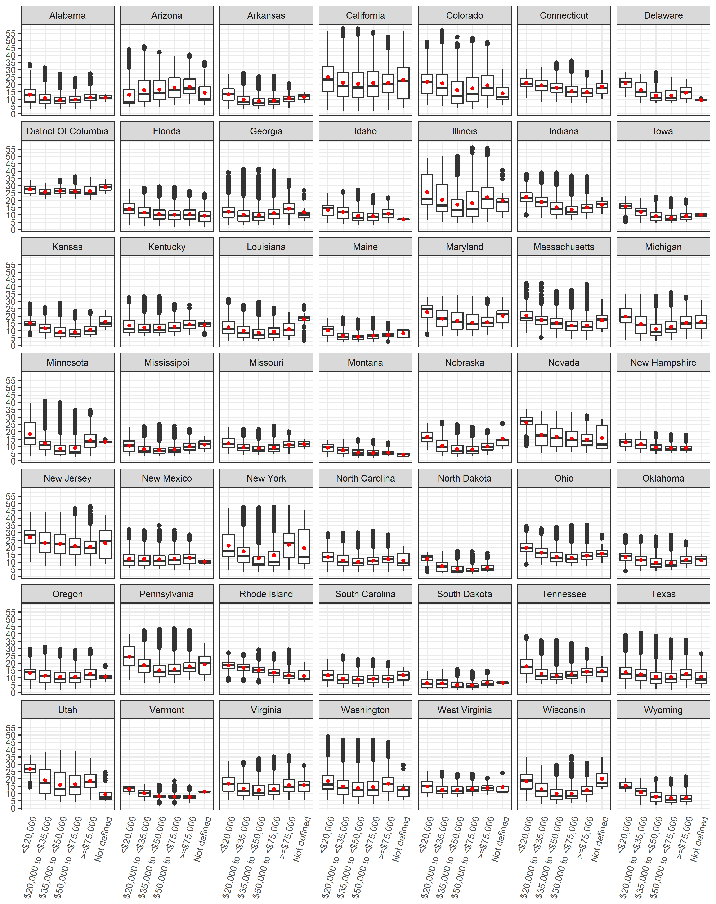

Figure S7: NO2 concentration (ug/m3) by state and living location

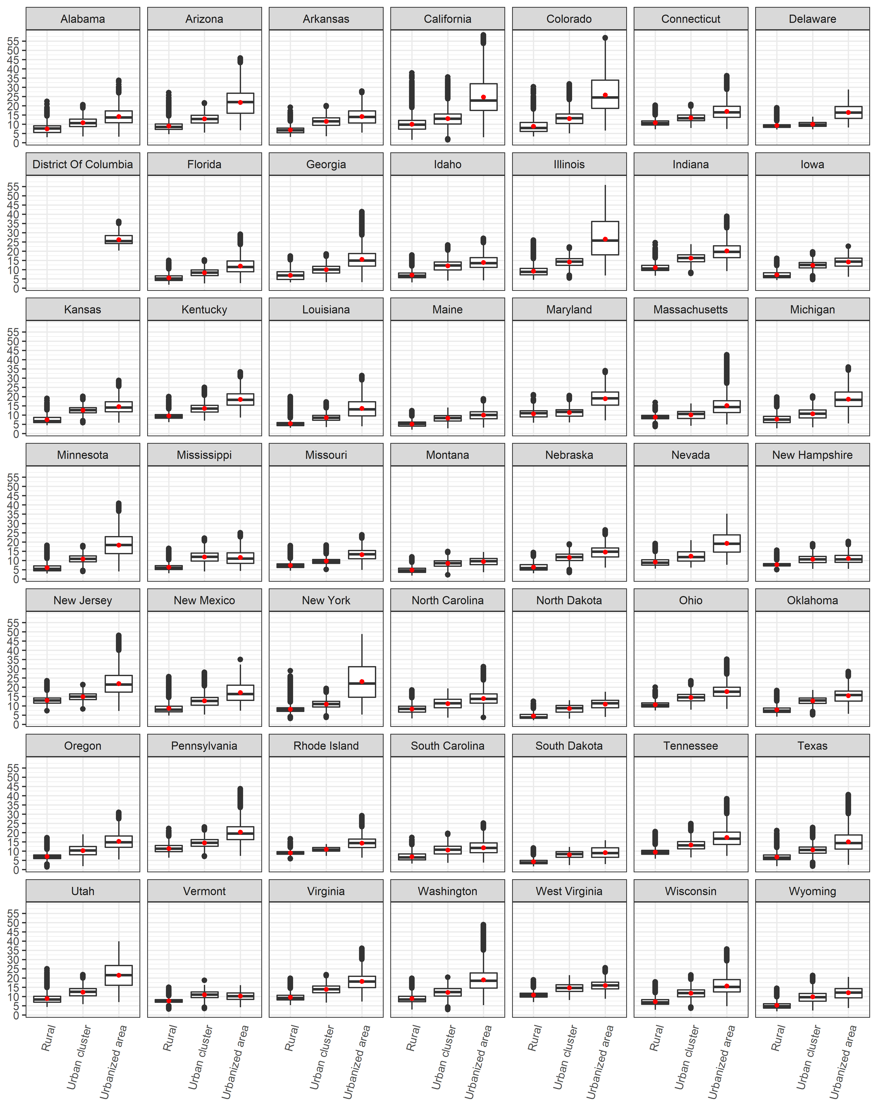

Figure S8: Attributable Fraction by living location

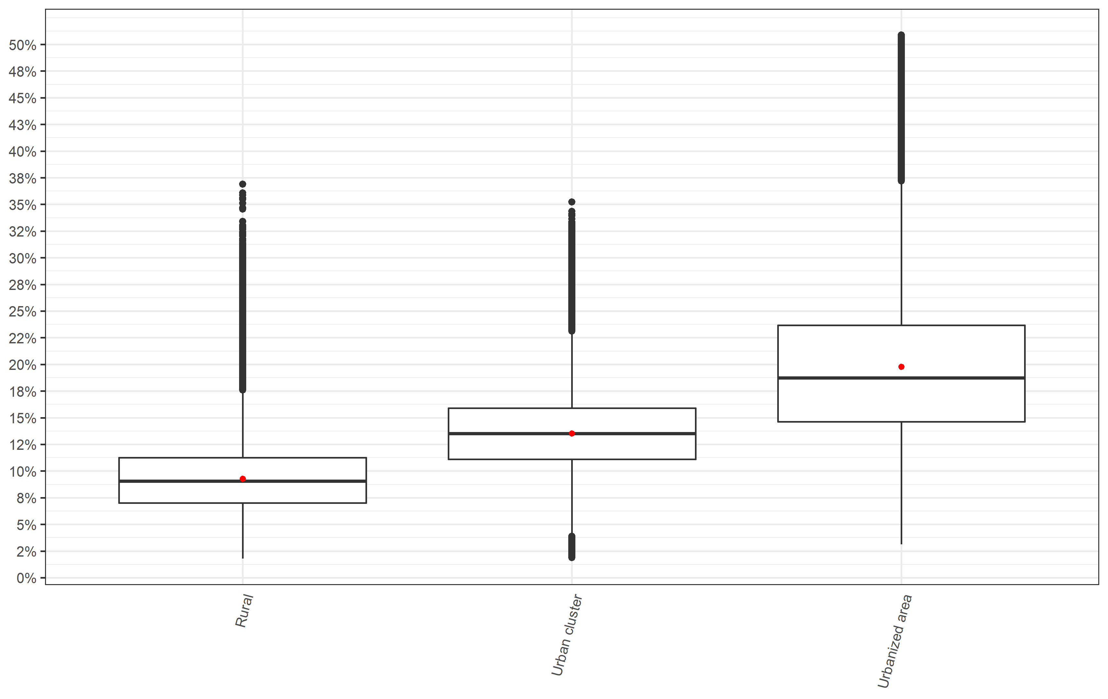

Figure S9: Attributable Fraction by median income group

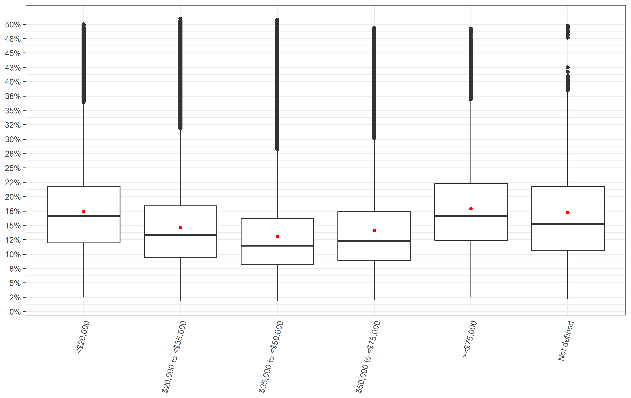

Figure S10: Attributable Fraction by median income group stratified into living location

